**Question 1**

1. **Formula for confidence interval.**

The formula for confidence interval is as follows:

$$p+z_{α/2}\sqrt{\frac{p(1-p)}{n}}<π<p-z_{α/2}\sqrt{\frac{p(1-p)}{n}}$$

Distribution of p can be assumed normal if following two conditions are satisfied:

$$1.n×p>5$$

$$2.n×(1-p)>5$$

As for condition 1, the product of n and p is 346.075 and for condition 2, the product of n and (1-p) is 288.925, the distribution of p can be safely assumed as NORMAL.

1. **95% Confidence Interval**

$$p-z_{α/2}\sqrt{\frac{p(1-p)}{n}}<π<p+z_{α/2}\sqrt{\frac{p(1-p)}{n}}$$

$$0.545-1.96\sqrt{\frac{0.545×0.455}{635}}<π<0.545+1.96\sqrt{\frac{0.545×0.455}{635}}$$

$$0.5063<π<0.5837$$

Through EXCEL, we can use CONFIDENCE Command as shown below:

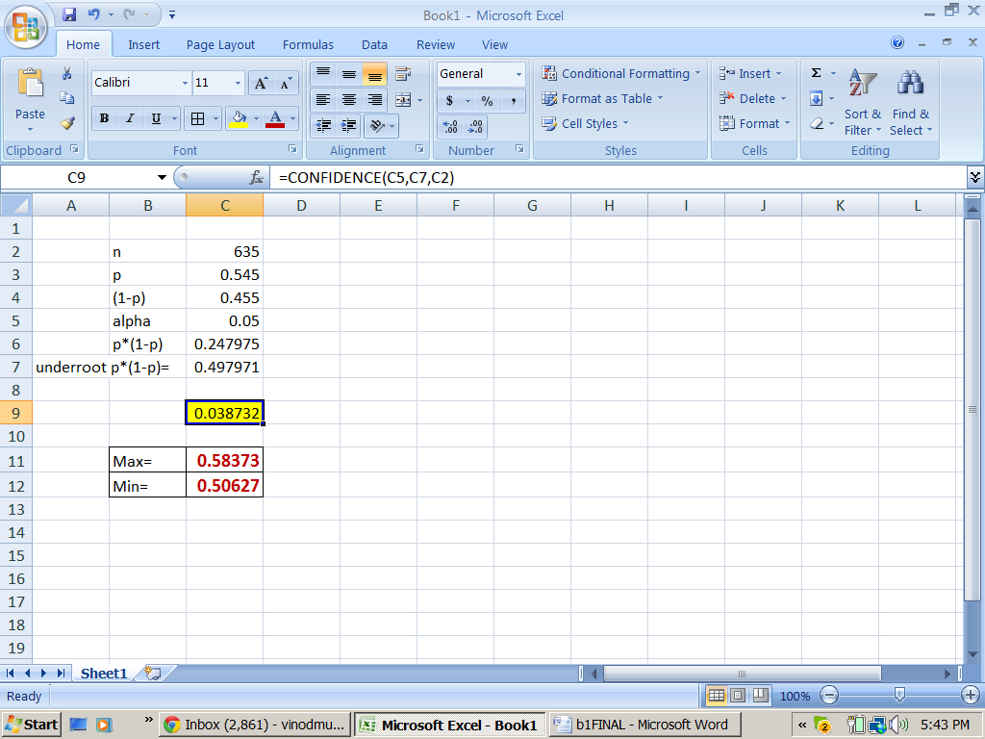

0.038732 is equivalent to the manual calculation of $1.96×\sqrt{\frac{p(1-p)}{n}}$

Following Figure shows the 95% Confidence Interval.

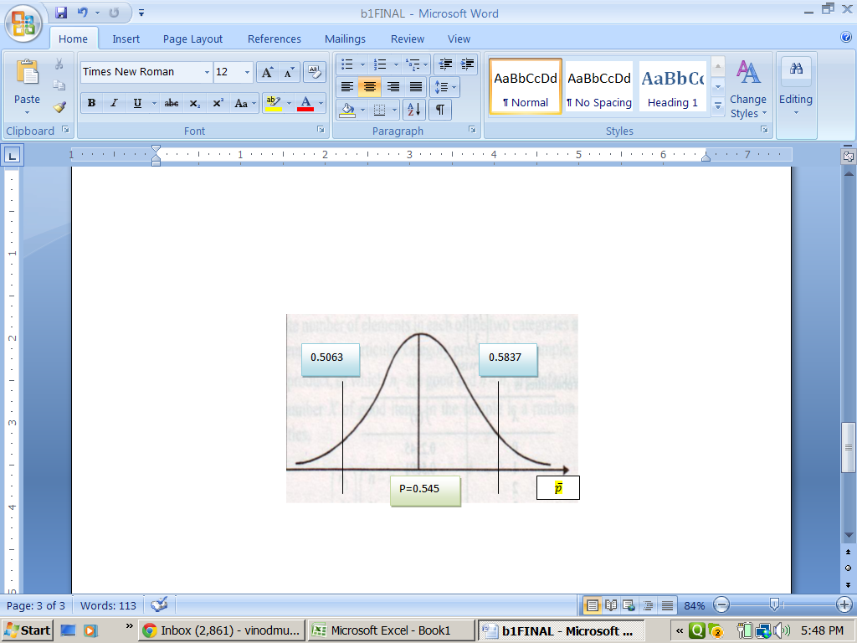

1. **If sample size changes to 100?**

The range becomes substantially wider as 0.4474 to 0.6626.

Reduction of sample size from 635 to 100 certainly reduces the power of the analysis, thus, the estimates.

1. **Critical Values at 5% level of significance**

Step 1:

$$H_{0}:p≤0.50$$

$$H_{a}:p>0.50$$

Step 2:

$z_{calculated}=\frac{\overline{p}-0.50}{\sqrt{{0.50 ×(1-0.50)}/{635}}}$ is distributed approximately as N(0,1)

$z_{calculated}=\frac{0.545-0.50}{\sqrt{{0.50 ×(1-0.50)}/{635}}}=2.27$

Step 3:

Critical Value of z: $z_{0.05, 1 tail}=1.645$

Step 4:

Reject the null hypothesis as Z calculated is > Z critical.

As Z calculated, 2.27 is > Z critical, 1.645, the null is rejected.

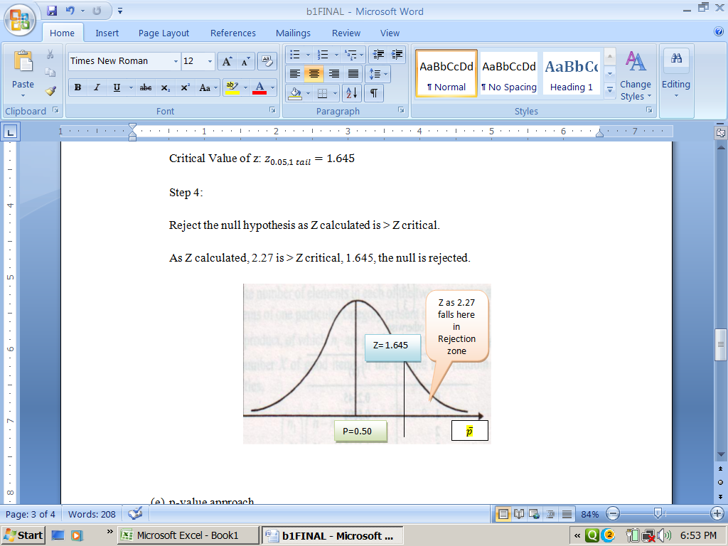

To get the full project, please buy the Assignment by using this Link

<http://sampleassignment.com/pay-now.html>

Cost - £9