|  |  |
| --- | --- |
|  | **[Year]** |
|  | [Type the company name] |

|  |
| --- |
| **[JOURNEY OF WALMART-IN INDIA]** |
| [Type the abstract of the document here. The abstract is typically a short summary of the contents of the document. Type the abstract of the document here. The abstract is typically a short summary of the contents of the document.] |

Table of Contents

1.0 INTRODUCTION 3

2.0 COMPANY PROFILE 3

3.0 INDIAN RETAIL MARKET 4

4.0 ENTRY TO INDIA: A JERKY JOURNEY 6

4.1 SHIFTING PSYCHOLOGY OF INDIAN CONSUMERS 8

5.0 FOREIGN DIRECT INVESTMENT IN INDIAN RETAIL SECTOR 10

6.0 POWER, PRESSURE AND POLITICS 11

7.0 WAMART-BHARTI VENTURE: TRANSFORMATION OF INDIAN RETAIL MARKET 12

8.0 ISSUES, CHALLENGES & RECOOMENDATION 13

9.0 CONCLUSION 15

10.0 REFERENCES 16

Figure 1: GROWTH OF RETAIL IN INDIA 5

Figure 2: AN IMAGE OF TRADITIONAL KIRANA SHOP 7

Figure 3:GROWTH OF ORGANIZED RETAIL 8

Figure 4: DISTRIBUTION OF INDIAN RETAIL MARKET 9

# 

# 1.0 INTRODUCTION

The present study discusses the journey of Walmart into an emerging economy India. The supermarket giant has established its presence despite many difficulties and struggled its way out to success. Though the future still seems bumpy for the company with the upheavals in unstable political scenario of India, the company is paving its way right to the minds of Indian Consumers (Reardon & Timmer, 2007). The case study discusses several aspects and issues regarding retail industries in India, political turmoil and struggle faced by the National and foreign retailers, difficulties to cope up with regional , local and national challenges of the diverse demographic and geographic spread and how the government and company can negotiate their understanding regarding mutual growth and development.

# 2.0 COMPANY PROFILE

Wal-Mart Stores Inc. was founded in 1962 and was formed into a legal organization on October 31, 1969. It runs the operation of retails stores in varied formats all around the globe. Wal-Mart follows a pricing policy known as “Everyday Low Prices” (ELP) where it quotes low prices for its items every day. Wal-Mart operates in three major fragments: the Wal-Mart U.S. section, Wal-Mart International section and the Sam’s Club section (Minot & Roy, 2007). In the financial year that ended January 31, 2012, the Wal-Mart U.S. section resulted in 60% (approximately) of its total net sales and is running retail outlets in varied formats in each of the 50 states of U.S. and Puerto Rico, and Wal-Mart’s online retail store, walmart.com as well. Wal-Mart’s International section is operating in 26 nations all over the globe (Walmart website, 2013). During the financial year 2012, this particular section has resulted in 28% of its net sales. The International section of Wal-Mart consists of varied formats of retail outlets, restaurants, online retail stores, and Sam’s Clubs operating outside the United States. Sam’s club section of Wal-Mart includes warehouse clubs as members operating in 47 states of the U.S. and Puerto Rico, and the online retail stores of this segment, samsclub.com as well. During the financial year 2012, Sam’s Club resulted in 12% (approximately) of the total net sales.

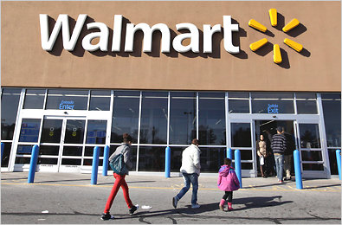

The company is engaged in multiple operations like: retail outlets situated all over U.S.; it’s totally owned subsidiaries situated in Brazil, China, Argentina, Canada, Japan and the UK; it’s majorly owned subsidiaries in Mexico, Chile, twelve countries from Africa, five nations from central America; it’s strategic partnerships in India and China and other controlled subsidiaries in China (Shukla, 2010). The U.S. section of the Wal-Mart section consists of the concept of mass merchant of the Company under the umbrella brand of Wal-Mart and walmart.com as well (Reardon & Timmer, 2007). The International segment of Wal-Mart includes the operations of the Company outside the U.S. The Sam’s Club section consists of the warehouse clubs as members in U.S. and samsclub.com as well.

# 3.0 INDIAN RETAIL MARKET

India was an attractive business zone from a time immemorial. The Post independence period experience economic struggle though, but since the economic liberalization in 1991, India is fast emerging as a strong economic power, with a huge market, The diverse and broad demography of India attracts many foreign investors in different business opportunities. The market size, availability of low cost labor supply, cultural, and geographical diversity are playing big role in attracting investors and giving the economy a fast improving pace (Kinra, 2006). Retailing in India is experiencing a huge growth, where the market generated almost US$395 billion; revenue in 2011 (GOI report:2012).India is appealing as far as retail business is concerned, with an expectation of growth up to US$785 billion by the end of 2014. Retail sector is the second largest employer in Indian economy and expecting a growth of 9.4% during financial year 2013-14 (Kaur & Singh, 2007). The increasing entry of foreign and national corporate companies in retail market there is a huge scope for retail industry’s growth and expansion, in developing countries like India. The retail industry is expected to reach a quantum leap of 40% annual compounded growth rate and revenue generation is supposedly expected to achieve a height of 1.3 trillion by 2018. Mckinsey report claims “the rise of Indian consumer market by 2025”, there is a four-fold growth expected in Indian Consumer Market (McKinsey report, 2011).

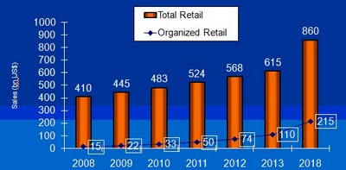

Figure 1: GROWTH OF RETAIL IN INDIA

Indian market is ripening with its over 250 million middle class populations, and economic growth rate of 9%. But the political regulations and unstable political climate of the country makes the Indian segment unpleasant for business (Swinnen & Vandeplar, 2007). It is only after November 2011, the Indian government announced for modification in retail policies for both multi-brand and single brand retailing. Despite of many political upheavals, and arguments from the opposition party, BJP, The central government opened avenues for foreign direct investment, by allowing foreign investors up to 51%, investment in multi brand retail (Agarwal & Bahree, 2011). This indicates FDI laws may be stringent for business growth and expansion but in a vast country like India, the obstacles can only be removed very patiently keeping in mind the unstable political scenario.

# 4.0 ENTRY TO INDIA: A JERKY JOURNEY

Instead of much attractiveness in Indian Retail and supermarkets, Walmart has faced many difficulties while entering India. The company planned an entrance to the Indian market back during 2005. But according to the Former president of Walmart, john Menzer, the company could not proceed because of regulatory obstacles (Kinra, 2006). Until 2011, the Indian Government Policy did not allow foreign investors for multi brand retail, ownership of supermarket, retail stores etc. A limitation on single branded retail was up to 51%, and governed by a bureaucratic procedure. During November 2006, Walmart went for a joint venture with Bharti. The early entry was much desired by the company, as they wanted to enhance opportunities emerging due to economic and consumerism boom in India. In the agreement with Bharti, the front-line business like stores and selling was managed by Bharti group, where as supply chain, back operations, management of logistics and resource utilization was managed by Walmart. Initially the format was launching small stores, making partnerships with local retailers in a franchisee based pattern (Joseph & Soundararajan, 2009). Walmart proposed to launch joint venture wholesale stores across 75 cities withing a short span of 7-8 years. Bharti group’s president Sunil Mittal claimed to procure 90% of the supplies from local farmers, producers, craftsmen and artisans (Raghunath & Mathur, 2005). The retail market comprises both organized corporate brands and disorganized small shops, popularly known as Kirana shops. The market leaders are still the widely spread small establishments, majorly owned by small shopkeepers or family businesses, who are more than 40 million in number. The foreign intrusion by giant retailers like Walmart, Tesco, Metro Cash & Carry, was not welcome by these small retailers, who feared of losing customers. People went on for rallies and opposition movements and huge labor unrest was seen in farmers, local producers, retailers against these foreign companies along with Indian retailers (Mukherjee & Patel, 2005). They were backed up by leading opposition party BJP who also was against the FDI deregulation on foreign investment by retailers.

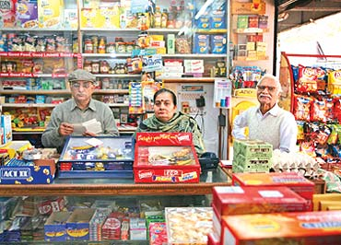

Figure 2: AN IMAGE OF TRADITIONAL KIRANA SHOP

Traditional unorganized retail market in India has been the easy entry for small shopkeepers and kirana stores. These small establishments like Kirana stores are basically the backbone of Indian Retail system, owned by self employment initiatives, or family business, with minimum investment in capital, labor and land (Joseph & Soundararajan, 2009). These kirana stores are located in streets, lane, right in the heart of city, in small urban and rural areas, in practically every streets and lanes, and thus forms a very convenient location for shopping. This system is deep rooted in Indian’s shopping and cultural habits, as most of the shopkeepers maintain their customer base on basis of a long established relational bond with their customers (Shukla, 2010). Though the Kirana stores generally serves the average need of Indian families, but they lack the provision of choosing from multiple available options, variety and the atmosphere of a highly modernized cultural backdrop.

# 4.1 SHIFTING PSYCHOLOGY OF INDIAN CONSUMERS

The Indian consumer market is going through a paradigm shift in consumption pattern. With significant change in typical joint family concept in India, nuclear families are emerging as a symbol of globalization. Increasing urbanization has caused a change in consumption pattern in India. After the economic liberalization took place in 1991, there is a flow of positive emotion towards organized retail sectors. Organized retail sector has invaded into even tier 1 and tier 2 cities (McKinsey Company report, 2011). India comprises of different states and broad population of people of different culture, language, religion, socio economic classes. They have varying purchasing power, different needs, demands, different set of value, practice and belief. All these make the task of a retailer difficult in assessing consumer’s buying pattern (Shukla, 2010).

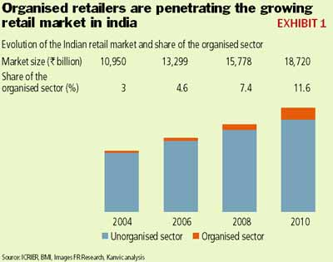

Figure 3:GROWTH OF ORGANIZED RETAIL

Indian consumer market was previously displayed by a pyramid, where a very small number of population from high end socio economic group was at the top of a pyramid, a relatively broad middle class segment and the biggest segment was at the bottom of pyramid, representing the underprivileged and deprived social strata (Lisbeth & Vlaho, 2007). But with increasing GDP growth at 7%, rise in disposable income, increased amount of purchasing power the pyramid is being replaced by a diamond, which represents a relatively high number of high end socio economic groups with affinity for luxurious living, and a huge number of middle class consumers, and lowest number of people from low economic zone (Swinnen & Vandeplar, 2007). With the Growing economic strength in Indian consumer market, where the main customers are the younger generation has a high affinity for branded products, increased purchasing power, affinity for luxurious living etc.

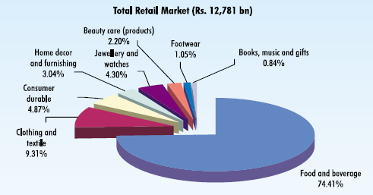

Figure 4: DISTRIBUTION OF INDIAN RETAIL MARKET

Though in retail industry consumers were habituated in buying from Kirana or Mom-& Pop shops, but with increased consciousness about brands in upper middle class segment, people are generally now looking beyond the utility effect of product (Sinha & Kumar, 2003). The better experience in shopping, increased shelf life for products, lifestyle statement attached with the branded product are offering the “wow” effect which is greatly missed by Kirana stores. Increased state to state migration for studies and job within the country has also impacted the need for retail and supermarkets in Indian young generation.

# 5.0 FOREIGN DIRECT INVESTMENT IN INDIAN RETAIL SECTOR

In spite of the fact that retail industry is one of the booming industries in India, and is expected to grow almost three times its current size to around US$ 660 billion by 2015, it has been one of the most least evolved industries and having a much slower growth in India compared to that of other parts of the world (GOI report, 2012). The major contributing factor for this abysmal

To get the full project, please buy the Assignment by using this Link

<http://sampleassignment.com/pay-now.html>

Cost - £19