Global Strategy and Competitiveness
EMBA 635

United Arab Emirates

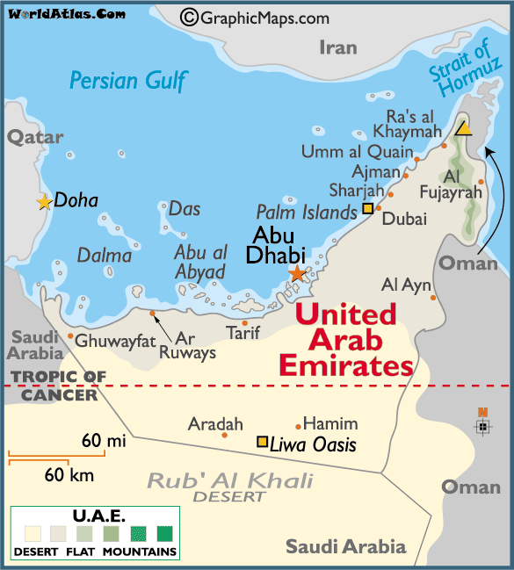
Image Source: WorldAtlas.com

Executive Summary

This report consists of environmental analysis of the United Arab Emirates to examine its attractiveness to foreign investment. It builds up a country profile of United Arab Emirates focusing on one emirate Dubai by examining factors such as economics, political, legal, finance, socio-cultural, and Foreign Direct Investment (FDI) to determine the stability and growth and also to analyze the government support and intervention to foreign direct investment. It evaluates the current scenario and projects possible forecasts for the near future.

Emirates Computers specializes in Risk management, Information Technology (IT) and Recruitment within the IT industry. With the advancement of modernization in UAE, IT is a very attractive business sector there. Also the different initiatives and policies set up by the Dubai government make Dubai a very promising place to set up a business in.

In summarization, UAE in general and Dubai in particular has had a very good economic growth and there is a lot of potential for further development although the current global financial crisis may slow it down a bit. Hence it is a good market for Emirates to enter but not at the moment, it should consider the possible outcomes of this economic downturn and then plan and proceed accordingly.

Table of Contents

Economic Statistics and Activity
A. Gross national product
1. Total
The Gross Domestic Product has seen a steady increase in the last 5 years and economists predict it to rise in the future (Department of Foreign Affairs and Trade, 2009).

<Source: Department of Foreign Affairs and Trade, 2009 >

- Growth Rate
The rate of growth was growing at constant levels till 2008 but has gone down in 2009.

<Source: Department of Foreign Affairs and Trade, 2009 >

B. Personal income per capita
Like Real GDP Growth Personal income per capita increased till 2008 and fell in 2009 as shown in the recent economic indicators figure above (Department of Foreign Affairs and Trade, 2009).
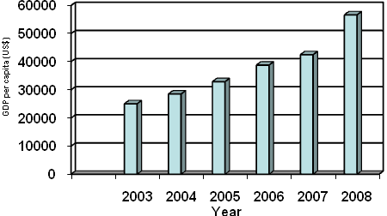
<Source: Department of Foreign Affairs and Trade, 2009 >
C. Average family income
The average monthly income for national households is AED 36,438.10 and expenditure is AED22,989, while non-national household income is AED15,074.30 and expenditure is AED9645.40 (Bundhun, 2009).
D. Distribution of Wealth
1. Income classes
The average monthly income for national households and non-national households is AED 36, 438.10 and AED 15,074.30, while the expenditure is AED 22,989 and AED 9645.40 respectively. (Bundhun, 2009)
2. Proportion of the population in each class
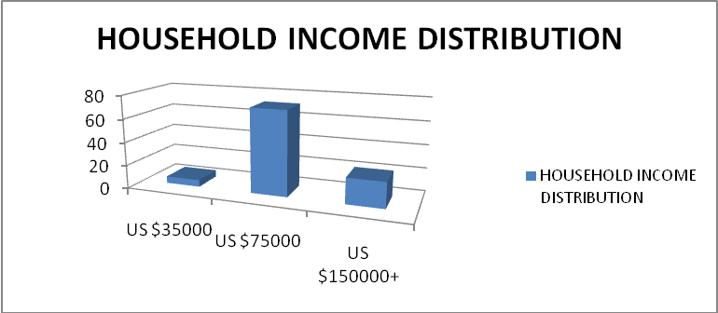
<Source: Euromonitor, 2009>

Majority of the population falls in the category of annual incomes of over US$ 75000. The country’s standard of living is one of the highest in the world. On a per capita basis, disposable income exceeds US$20,000 per year (Euromonitor, 2009).

- Is the distribution distorted?
Country’s richest 10% of households accounted for 29.1% of household disposable income in 2008 showing that distribution is distorted (Euromonitor, 2009).

E. Minerals and Resources
Natural gas and Oil are the primary natural resources along with petroleum production being the most important industry. The economy of UAE is dominated by gas and oil sector. The Supreme Petroleum Council, which is headed by the crown prince of Abu Dhabi controls energy policies (Library of Congress, 2007).
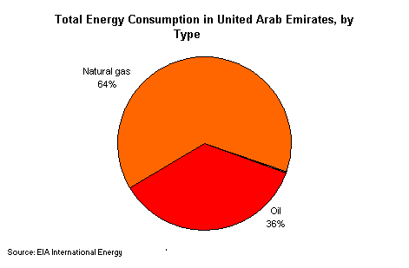

F. Surface transportation
1. Modes
The main modes of transport include Roads (total: 4,080 km paved: 4,080 km (includes 253 km of expressways), Ports, Inland Waterways, Civil Aviation and Airports an d Pipelines. (Library of Congress, 2007) (Middle East directory, 2008).
- Availability
The planned US$20.4 billion investment in airport infrastructure over the next 20 years could increase passenger traffic exponentially (Library of Congress, 2007).
- Usage Rates

Table 1 Transportation Sales by Sector: Value 2002-2007

AED million
2002 2003 2004 2005 2006 2007

Airline seats sold 27,700.0 28,800.6 37,600.8 39,801.5 43,201.8 49,003.0
- Schedule 26,000.0 27,000.0 35,000.0 37,000.0 40,000.0 45,000.0
- Charter 1,700.0 1,800.0 2,600.0 2,800.0 3,200.0 4,000.0
- Low cost carriers - 0.6 0.8 1.5 1.8 3.0
Other transportation 141.3 161.7 203.7 239.9 266.1 294.9
- Bus/coach 75.0 92.0 131.0 165.0 171.5 188.7
- Chauffeur-driven car 66.3 69.7 72.7 74.9 89.7 100.5
- Cruise - - - - 2.6 3.2
- Ferry - - - - 2.2 2.5
- Rail - - - - - -
Transportation 27,841.3 28,962.3 37,804.5 40,041.4 43,467.9 49,297.9
Source: Euromonitor International
<Source: Euromonitor, 2009>

- Ports
In addition to the two major facilities in Dubai, Jebel Ali and Port Rashid, Sharjah city has a port and the emirate has another in its Khor Fakkan enclave on the Gulf Oman.
G. Communication systems
1. Types
Etisalat is the state telecommunications operator maintains and operates various types of communication systems namely fixed telephone line network, mobile telephony and cable TV services (Library of Congress, 2007).
- Availability
There are 1.3585 million main lines of telephone along with 7.595 million mobile cellular (Middle East directory, 2008).

3. Usage Rates
The UAE also has the lowest mobile-phone rates in the Arab world (US$0.06 per minute). (Library of Congress, 2007)

H. Working conditions
1. Employee relations
There is a contract between the employer and the employee which is a written document which commits both parties to abide by the relevant UAE’s labour law and company policies and procedures. And whilst this written contract is important it is not the only "contract" that exists between employers and employees (Arabia n Business, 2009).

2. Employee participation
The employees in the UAE generally have a say in the management activities and their advise and suggestions are highly regarded.

- Salaries and benefits
The salary levels are similar and even higher than those paid in W Europe. The salary includes basic salary, housing allowance, car allowance, medical coverage and more. On average the salary packages for a professional with 5 years plus experience are between 25,000 and 40,000 dirhams per month - obviously depending on age, experience, specific expertise etc . (Conduit Group, 2009) (Newman LS, Associated Content, 2007)

I. Principal industries
1. What proportion of the GNP does each industry contribute?

2. Ratio of private to public owned industries
No date available.
J. Foreign investment
1. Opportunities
The period just before the economic crisis (2003-2006) saw an increase in foreign investments into the country largely due to factors such as the UAE's growing status as a regional economic and trade hub, its economic and political stability and the free market approach to business in addition to the availability of advanced infrastructure. UAE ranked number 15 worldwide on Inward FDI Performance Index.
2. Which industries?
Non-Arabic investments concentrate on strategic and important sectors, such as insurance, financial brokerage, contracting and construction, retail trade, transformational industries, transport and telecommunication, water and electricity and the oil industry. Arabic investments, conversely, concentrate on light industries, real estate and stocks
K. International trade statistics
1. Major Exports
A. Dollar Value
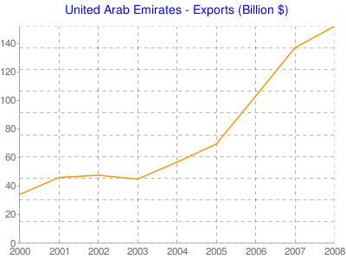

Year | Exports (Billion $)
2000 | 34
2001 | 46
2002 | 47.6
2003 | 44.9
2004 | 56.73
2005 | 69.48
2006 | 103.1
To get the full project, please buy the Assignment by using this Link
http://sampleassignment.com/pay-now.html
Cost - £29

