**Data Communication, Network and Digital Communication**

# **Contents at a Glance**

Contents at a Glance 2

Introduction 3

Setting up The Solar System: 7

Method to implement the network: 8

Details of the Sun Core: 8

Setup between Mercury and Venus: 9

Setup between Venus and Earth: 10

Setup between Earth and Mars: 11

Setup between Mars and Jupiter: 11

Setting up the Moon Base Alpha: 12

Setting up the Asteroid Belt: 13

Hosting the Calisto server: 15

Hosting the Io server: 16

Conclusion 18

References 19

# **Introduction**

**Importance of Computer Network in today’s life:**

Computer networking and data communication is the hottest field of study all over the world.When started it was considered mainly the research areafor thetechnology people working on network engineering domain. But today it involvesalmost everybody in the world. From transportation to Shopping, Communication Media and Entertainment everywhere we have made extensive use of networking. Even socializing got its electronic form these days. Today it’s virtually impossible for almost everybody to live a day without making use of the computer network in some form directly or indirectly.

Let’s understand the basic of the computer network and its jargons:

**What is a Network& what are its Components:**

In simple words a network is a collection oftwo or more devices linked to each other for the purpose of sharing information and/or resources. The connections between these devices are established using either (physical) cable or wireless media. The network devices that originate, route and terminate the data are called nodes which can be a computer, printer, router or any other peripheral devices. (Olivier 2010)

Depending on the size and use of network we have different networking systems as:

* PAN: Personal Area Network
* LAN: Local Area Network
* MAN: Metropolitan Area Network
* WAN: Wide Area Network

To establish and maintain astandardized data communication a set of rules/conventions and data structure have been developed which governs the way all the network devices communicate over the network. This set of rules/standards is called Network Protocol. (Lowe 2010)

**Modern Network Architecture and TCP/IP Protocol:**

The modern Internet Protocol Scheme widely known as TCP/IP is the basic of all networking. As discussed earlier this protocol is capable of both wired and wireless exchange of data across any networking device. This protocol defines the base of communication such as the addressing of the devices, communication between them and security over the entire networking system(Stallings 2007).

IPv4or the Internet Protocol version 4 is the fourth version of the protocol designed. Today this version is the most widely used across globe.It is commonly known as TCP/IP (RFC 1122 October 1989), as the primary(first) protocols defined in this this scheme were Transmission Control Protocol (TCP) and the Internet Protocol (IP). **IPv4** uses 32-bit (4 Byte) address for defining any device and the address is noted in dotted quad notation. Because of using only 32 byte for the address representation it limits the address space to 4,294,967,296 (232) addresses. Every network has the basic 2 address structures: one for the network and another for its broadcasting.  Where the Network address has all its host bits as "0"the BroadcastingIP address’ host bits consists of "1"s.

To calculate the number of possible IP address we can use the following equation:

Number of possible IP addresses = (2n)–2) ---("n" defines the number of bits in host part). (Miller 2010)

The dotted quad notation:

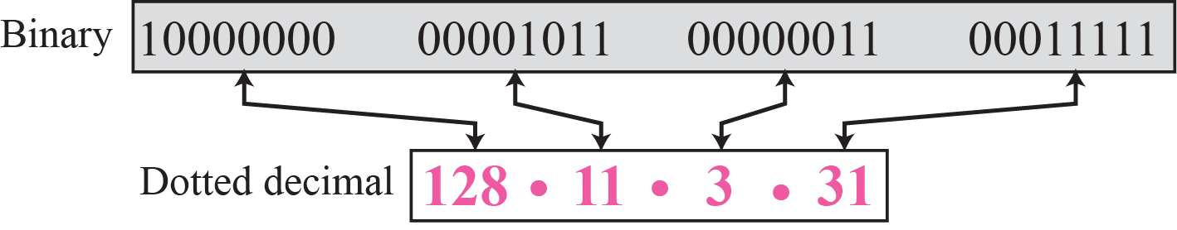

The TCP/IP standard consists of several protocols for defining and managing the data communication: (Miller 2010)

* TCP (Transmission Control Protocol): This protocol defines the communication between various applications
* IP (Internet Protocol): The address based protocol defines the communication between nodes.
* ICMP (Internet Control Message Protocol): This protocol is used for defining and analysing errors and statistics
* DHCP (Dynamic Host Configuration Protocol): The host address could be static or dynamic. This protocol is used to make dynamic address for the host.

**Concept of Layering in TCP/IP model:**

There are essentially 4 layers of TCP/IP Model:

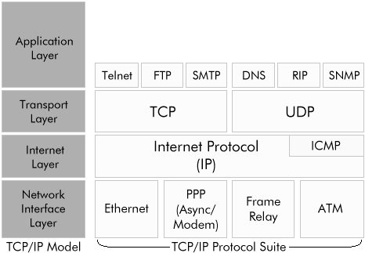

Pic: TCP/IP Layer (Hallberg 2009)

1. **Network Interface Layer:**It is the base layer of TCP/IP model which is responsible for packet data communication between devices via the internet media. As TCP/IP is not dependant on the network accessing method or the frame format it can be used to connect LAN (Ethernet and Token Ring) and WAN technologies.
2. **Internet Layer:**For communication between devicesthe other basic functions are addressing, packaging, and routing. Internet layer establishes that.There are various protocols defined in this layer:

* The *Internet Protocol* (IP): This protocol defines the IP addressing (in dotted quad notation), routingand the fragmentation of the packets over the internet and reassemble the packets on receiving.
* The *Address Resolution Protocol* (ARP): This protocol resolute the Internet layer address to the node’s hardware address.
* The *Internet Group Management Protocol* (IGMP): This protocol defines the management of IP multicast groups
* The *Internet Control Message Protocol* (ICMP): This protocoldefines the diagnostic functionality of packet transmission and reports errors on unsuccessful delivery of data packets.

1. **Transport Layer**: The Transport layer defines how to provide the Application layer with session and datagram communication services. Various protocols defined under this are:

* Transmission Control Protocol: This protocol definesthe logic of communication service between nodes. This protocol controls the delivery and sequence of packets sent and received by the nodes.
* User Datagram Protocol: This provides unreliable communications service between 1-1 or 1-many devices. For small data transmission UDP is used.

1. **Application Layer:**The *Application layer* defines how the various applications should access the services of the other layers and different protocols to rule the application for communication.

The most used Application layer protocols are:

* + File Transfer Protocol (FTP): This is used for interactive file transfer.
  + Telnet: This is a terminal emulation protocol and used for remote log in to different network hosts.
  + Simple Mail Transfer Protocol (SMTP):This is used for the transmission of mail messages and attachments.
  + Hypertext Transfer Protocol (HTTP): This protocol is used to transfer files in the Web pages of the WWW domain.

**Address Allocation in IPv4 Topology (CLASSFUL Addressing):**

IP addresses, when started a few decades ago, used the concept of classes. This architecture is called classful addressing. In the mid-1990s, a new architecture, called classless addressing, was introduced that supersedes the original architecture.

Originally, an IPv4 address was divided into two parts: the network identifier was the most significant (highest order) octet of the address, and the host identifier was the rest of the address. The latter was therefore also called the rest field. This enabled the creation of a maximum of 256 networks. This was quickly found to be inadequate.

To overcome this limit, the high order octet of the addresses was redefined to create a set of classes of networks, in a system which later became known as classful networking (RFC 791 1981). The system defined five classes, Class A, B, C, D, and E. The Classes A, B, and C had different bit lengths for the new network identification. The rest of an address was used as previously to identify a host within a network, which meant that each network class had a different capacity to address hosts. Class D was allocated for [multicast](http://en.wikipedia.org/wiki/Multicast) addressing and Class E was reserved for future applications. (Kundu 2008)

The following table shows different classes of IPv4 addressing scheme with their ranges:

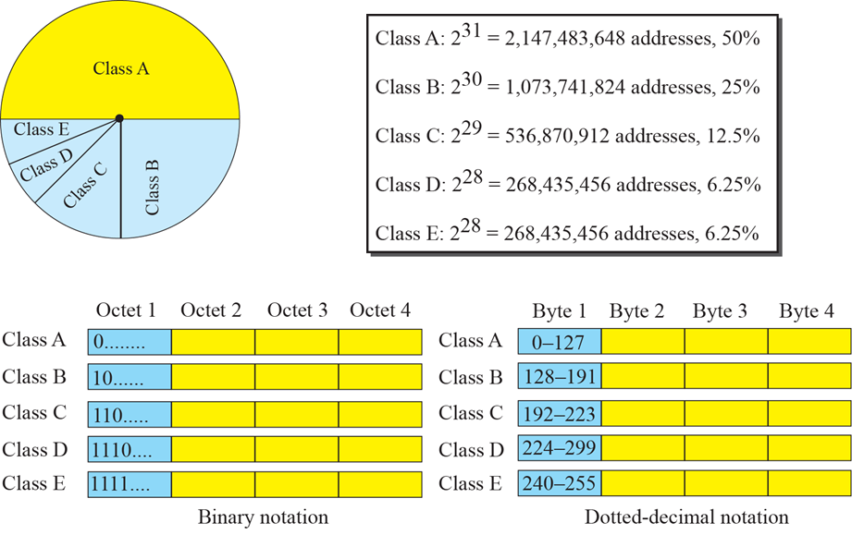

In classful addressing, an IP address in class A, B, or C is divided into netid and hostid.

These parts are of varying lengths, depending on the class of the address.











**Subnet System& Private Network:**

Sub-networking technique is used to subdivide the huge network with millions of potential hosts into manageable sections, namely subnets.Subnet is a logically visible subdivision of an IP network. Concept of extended network IP addresses to individual nodes is vastly used in subnetting. The extended network address consists of both a network address and additional bits which defines the subnet number.(Hallberg 2009)

Private Network: A private network is a network that uses private IP address space, defined in the standards set by RFC 1918 for IPv4. These kind of private addresses are used by home networks, internal office network such as LAN when global address are not available for the intended network applications or not mandatory. Under IPv4, to compensate the exhaustion of IP address Private address were created.

The IETF (Internet Engineering Task Force) has directed the Internet Assigned Numbers Authority (IANA) to reserve few IPv4 address ranges for private networks. This is published in RFC 1918.

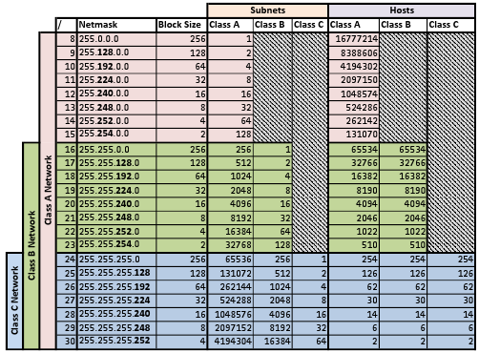

**Pic: Subnet Table based on different classes (RFC 1878)**

# **Case Study: Setting up The Solar System:**

Our assignment is aimed to develop and implement a computer network schematic called “solar system” using Class B public addressing scheme of Internet Protocol version 4 (IPv4). The pictorial architecture of the network is as shown below:

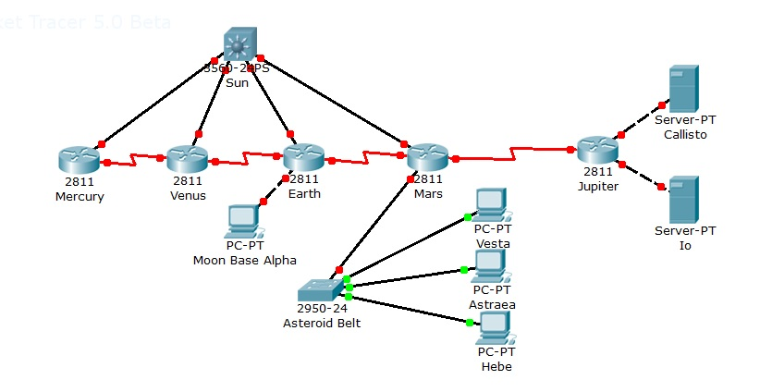

## **Method to implement the network:**

The following image shows the graphical solution including IP addresses and subnet masks:



### **Details of the Sun Core:**

* The Sun Core subnet contains 5 routers and 1 unmanned switch.
* The subnet mask is set to 255.255.240.0 so that this network can contain total 16 subnets along with 4094 hosts per subnet to horizontally scale itself when required.

To get the full project, please buy the Assignment by using this Link

<http://sampleassignment.com/pay-now.html>

Cost - £19