

CASE STUDY OF VODAFONE



**Role of Training and Development in Employee Retention**



**Case Study of Vodafone**

# 

# ABSTRACT

Employees are the strategic asset of any organization; this talent has to be managed and preserved. This project presents a descriptive study, which mainly investigates on the functioning and role of training and development in employee retention, a case study of VODAFONE, a leading telecommunication company of UK, has been presented in this research. This study also investigate on the significance of training and development in managing of employees, different types of training methods in use, and its effects on retention of employees and about benefits which company gains as well. The study mainly helps in finding about the benefits of training and development in retention of employees as well as about the retention of companies information as well. This study emphasizes the role of training and development plays a very crucial role in retaining the capable employees, which are the precious assets treasured by all organizations.

Keywords: retention, T&D (Training and Development), Vodafone

Contents

[Abstract 2](#_Toc277831845)

[Acknowledgements 3](#_Toc277831845)

[CHAPTER 1: INTRODUCTION 4](#_Toc277831845)

[1.1-Introduction 4](#_Toc277831845)

[1.2-Research Background 5](#_Toc277831845)

[1.3-Organisation Background 8](#_Toc277831845)

[1.4-Purpose of undertaking Research 9](#_Toc277831845)

[1.5-Rationale for Choosing this Topic 9](#_Toc277831845)

[1.6-Statement of Problem 9](#_Toc277831845)

[1.7-Research Questions 10](#_Toc277831845)

[1.8-Main Aims and Objectives of the Research 10](#_Toc277831845)

[1.9-Scope of the Research 11](#_Toc277831845)

[1.10-Research Methods 11](#_Toc277831845)

[1.11-Structure of the Dissertation 11](#_Toc277831845)

[1.12-Summary of the chapter 12](#_Toc277831845)

[CHAPTER 2 - LITERATURE REVIEW 12](#_Toc277831845)

[2.1-Introduction 13](#_Toc277831845)

[2.3-Increased employee Turnover 14](#_Toc277831845)

[2.4-Calculation of Retention 14](#_Toc277831845)

[2.5-Types of employee Turnover 15](#_Toc277831845)

[2.6-Adverse effects of increased employee Turnover in an Organization 15](#_Toc277831845)

[2.7-Elevated financial expenditure of Turnover 15](#_Toc277831845)

[2.8- knowledge drain, an asset of the organization 16](#_Toc277831845)

[2.9- Weakens Customer and Clients relationships 16](#_Toc277831845)

[2.10-Low productivity until the new Employees are completely Trained 16](#_Toc277831845)

[2.11-Turnover leads to more Turnovers. 16](#_Toc277831845)

[2.12 Fundamental reasons of increased employee Turnover 16](#_Toc277831845)

[2.13-Internal & External factors 17](#_Toc277831845)

[2.14-Importance of retention in an Organization 17](#_Toc277831845)

[2.15-Which employees must be retained. 18](#_Toc277831845)

[2.16-Role of Motivation and Professional satisfaction in retention of Employee. 19](#_Toc277831845)

[2.17-Advantages of Employee retention to the Organizations 19](#_Toc277831845)

[2.18-Retention saves new Recruiting Expenses and Time 19](#_Toc277831845)

[2.19-Retention helps to retain company’s Information or Knowledge 20](#_Toc277831845)

[2.20-Various options Offered to retain Employees 20](#_Toc277831845)

[2.21 –Do not call Employees to work during planned Off days 21](#_Toc277831845)

[2.22-Offering competitive pay rates to the Employees 21](#_Toc277831845)

[2.23-Increasing employee Interactions and Engagements 21](#_Toc277831845)

[2.24- Promotions, Rewards, and Appreciations of the top Performers 22](#_Toc277831845)

[2.25- Maintaining the employees Training & Development Program 22](#_Toc277831845)

[2.26- Relationship of Training and Development with Employee Retention 23](#_Toc277831845)

[2.27- Components of employee Training and Career Development Programs 24](#_Toc277831845)

[2.28-Encouraging Learning and Development Programs 25](#_Toc277831845)

[2.29-Streamlining the process of Training and Development Programs 25](#_Toc277831845)

[2.30 Planned Direction of Training and Development Programs 26](#_Toc277831845)

[2.31-Hierarchy of Training and Development Programs 27](#_Toc277831845)

[2.32-Effective implementation of Training & Development Programs 29](#_Toc277831845)

[2.33-Process of Implementation of Training & Development Programs 30](#_Toc277831845)

[Figure, 2.9The model implemented by Mictel Solutions 32](#_Toc277831845)

[2.34-Continuing Education in Employee Training 32](#_Toc277831845)

[2.35-Formal and Informal approach of Training and Development 33](#_Toc277831845)

[The off-the-job training and development program flow chart of the Honda Company is given below: 35](#_Toc277831845)

[Figure, 2.9 Hondas off Job Training Model. 35](#_Toc277831845)

[2.38-Need and Advantages of Training and Development of Employees 36](#_Toc277831845)

[Figure 2.10 Dr. Alan Nankervis & Dr. Cecil Pearson (2010) Training and Development Programme 37](#_Toc277831845)

3.[Vodafone UK: Company overview 37](#_Toc277831845)

3.1[Introduction 37](#_Toc277831845)

3.2[Mission Statement of the Company 38](#_Toc277831845)

3.3[History 39](#_Toc277831845)

[3.4. 41](#_Toc277831845)

[3.5Vodafone launches the Vodafone Sure Signal 41](#_Toc277831845)

3.6.[Critical Analysis of the strategy 41](#_Toc277831845)

[3.7.Vodafone UK get in touch with the SMEs with Revamped ‘Vodafone Partner Services 42](#_Toc277831845)

3.8.[Critical Analysis 42](#_Toc277831845)

3.9.[Competitive Concerns 43](#_Toc277831845)

3.10.[Importance of the Vendor 43](#_Toc277831845)

3.11.[Market Impact 43](#_Toc277831845)

3.12.[Business description of the company 43](#_Toc277831845)

3.13.[Research and Development practices by the company 44](#_Toc277831845)

3.14.[Human Resource Practices in the Company 45](#_Toc277831845)

3.15.[Diversity and Inclusion in Vodafone Family 46](#_Toc277831845)

[Chapter four-Research Methodology 46](#_Toc277831845)

[4.1 Research Methodology 46](#_Toc277831845)

[4.2 RESEARCH PROBLEM: 46](#_Toc277831845)

[4.3 OBJECTIVES OF THE STUDY: 46](#_Toc277831845)

[4.4 HYPOTHESIS: 46](#_Toc277831845)

[4.5 DATA COLLECTION METHOD: 46](#_Toc277831845)

[4.6 Research Methods: 47](#_Toc277831845)

[4.7 DATA COLLECTION SOURCES: 47](#_Toc277831845)

[4.8 RESEARCH DESIGN 47](#_Toc277831845)

[4.9 SAMPLING DESIGN 49](#_Toc277831845)

[4.10 SAMPLING TECHNIQUE: 50](#_Toc277831845)

[4.11 SCOPE OF STUDY: 50](#_Toc277831845)

[4.12 RELEVANCE OF THE STUDY: 51](#_Toc277831845)

[4.13 QUALITATIVE RESEARCH: 52](#_Toc277831845)

[4.14 QUANTITATIVE RESEARCH: 52](#_Toc277831845)

[4.15 INDUCTIVE RESEARCH: 52](#_Toc277831845)

[4.16 JUSTIFICATION: 53](#_Toc277831845)

[4.17 RELIABILITY: 54](#_Toc277831845)

[4.18 VALIDITY: 54](#_Toc277831845)

[4.19 ETHICAL ISSUES: 54](#_Toc277831845)

[4.20 DATA ANALYSIS: 54](#_Toc277831845)

[4.21 LIMITATIONS OF THE STUDY: The limitations of the study can be stated as under: 55](#_Toc277831845)

[4.22 SUMMARY. 56](#_Toc277831845)

[Chapter 5 – Data Analysis & Findings 56](#_Toc277831845)

5.1[Introduction 56](#_Toc277831845)

5.2[Model used by Vodafone-UK Management 58](#_Toc277831845)

[The ADDIE Model 58](#_Toc277831845)

5.3[Interview findings 59](#_Toc277831845)

5.4[Findings of Questionnaires 63](#_Toc277831845)

5.5.[Analysis 74](#_Toc277831845)

[CHAPTER 6: CONCLUSION AND RECOMMENDATIONS 79](#_Toc277831845)

[6.1-Introduction 79](#_Toc277831845)

[6.2-Conclusion of the study 80](#_Toc277831845)

[6.3-Limitations of the research 83](#_Toc277831845)

[6.3.1- Concluding research with in the time span available for research 83](#_Toc277831845)

[6.3.2 - Gaining trust of employees to give correct and candid reply 84](#_Toc277831845)

[6.3.3- Challenge in selection of appropriate candidates for the survey 84](#_Toc277831845)

[6.3.4- Sharing sensitive data of the organization 84](#_Toc277831845)

[6.4-Recommendations 84](#_Toc277831845)

[6.4.1- Recommendations for the organizations 85](#_Toc277831845)

[6.4.2-Recruitemnt criteria of new employees to be more aligned with goals 85](#_Toc277831845)

[6.4.3-Proper and clear communication with the new employees 85](#_Toc277831845)

[6.4.4- Conducting induction program for new employees 85](#_Toc277831845)

[6.4.5-Offering flexible working schedule 85](#_Toc277831845)

[6.4.6- Creation of a pleasant working environment 86](#_Toc277831845)

[6.5.-Recommendations for future researchers 86](#_Toc277831845)

[6.5.1-Clear communication with the participants of the study 86](#_Toc277831845)

[6.5.2- Increase participants to reduce any form of bias in results 86](#_Toc277831845)

Biblography 86

References-------------------------------------------------------------------------------------------------------

Appendix-1------------------------------------------------------------------------------------------------------

Appendix-2---------------------------------------------------------------------------------------------------------------------------

# Acknowledgements

First of all I am very thankful to Almighty **‘GOD’** who gave me the strength, passion, zeal and courage to accomplish every phase of my research.

I also sincerely thank  **-------------** and **UWIC** for making me a part of recognised institutions and also **for** providing me an opportunity to explore my knowledge for my MBA thesis.

I also would like to thank whole heartedly ***XYZ*** my dissertation supervisorfor his encouragement, precious guidelines, and valuable assistance and continues support in all stages throughout this research. Without his guidance I would have not completed this project successfully.

I would like to thank my friends Mr&Mrs Nagpaul, Zeena, Ejay and Muskan Jahan for their exciting support, loving care and encouragement throughout the phase of this study.

I really appreciate and thank all my friends for the sensible continuous practical support given to me for holding on to the most traumatic and stressful situations during the whole period of my research.

I am very thankful to the employees at **“**Vodafone, UK.” for sharing their valuable experiences, and for the co-operation during my study.

# 

# CHAPTER 1: Introduction

## 

## 1.1-Introduction

In today’s dynamic environment of business, customers do not have the time and patience to wait for a company’s response to a change and then buy the product. It is expected that company either is proactive to change or is the one who is responsible for the change. There is no word called “Loyalty” now, when it comes to customers. When a customer feels that he is not being given service properly by the company or pace of the company is slow, he never hesitates to “Switch” over to another company. (Author: Bradlley Mckoy, 2009).

This holds true for all the businesses today since the competition is so intense and the number of companies have also increased manifold. There is no monopoly seen in a particular business in recent times. So a company has to have an edge over its competitors to survive in the business. Michel.N.Abrams (2009).

The company which the researcher has taken for the study is Vodafone, which is a leading company in the telecommunication sector. It is a customer oriented service industry. The companies have to realize that the customer expectations are high and it is not Customer Service, Customer Delight but Customer Ecstasy, which is the order of the day. The customers have to be given ecstatic service in such a way that they would never think of switching over to another company.

To achieve the above mentioned, the company should not only be proactive to changes but make the employees also accept change as and when it approaches the company. We now live in an era where there is no simple leadership but it is expected that the people to be e-leaders or electronic leaders. They have to take care of their Human Resources and make them perform effectively from anywhere and at anytime.

This section concentrates on the subject of basic study of ‘The function of training and development in employee retention at UK Vodafone’. The second half of this chapter will discuss the major goals and questions together with the methodology for data gathering. In addition, at the end of this chapter, constraints that could be faced in the course of the research will be covered. The outline of the methodology adopted for the study will also be touched upon.

## 1.2-Research Background

Today’s world is brimming with change, complexity and difficulty. It is difficult for any business to work without extremely high talent and if they are not being prepared to lead the organization's survival in the competition around them. With the increased number of new companies and businesses and the continued progress of modern techniques, organisations have realised how valuable their employees are to them. As stated by Ljungberg and Larsson (2005), most companies now consider the workforce as significant contributors, and pay greater attention towards their administration in the organisation.

Over the years, the rate of employees’ turnover has shown a steady increase. The employees today do not have in them, the company faithfulness and loyalty that existed earlier. After the rise in acquisitions and mergers of businesses, employees developed the impression that they were being distanced from the business process, and resultantly their jobs with their companies were no longer stable. Consequently, the employees began to move deliberately in search of safer and more secure job options.

Although several companies do succeed in recruiting good employees, that by itself is not sufficient for the company’s progress. What is essential is to make these employees stay longer with the company and decrease the resignation rates. In some organizations the rate of staff turnover is naturally high due to the nature of the job, but in several companies this phenomenon of high turnover could be detrimental to the company’s health, especially in organisations that focus on communications for customer service and quality (Curtis and Wright 2007).

This upsurge in the staff turnover rate, as well as the anxiety it causes at the managerial levels to prevent this trend result in financial problems for the company. Kay (2009:2) attempts to justify these expenses by the statement “.advertising and recruiting expenses, decreased productivity until the new employee is fully up to the speed and the loss of customers who were loyal to the departing employee”.

As stated by Curtis and Wright (2007), replacing any member of the key staff can cause a cost liability of up to 150 percent of the annual salary of the member replaced. There are also other downtimes for temporary replacement, preparation, knowledge enhancement etc. In addition, where the company’s annual profits are high, the employees become apprehensive that the company is not steady and safe, giving rise to problems amongst the employees. Therefore, the high cost that is incurred on the company makes it essential to have an effective strategy for retention of employees.

As stated by Tsai and Tai (2005), advance programs and training is a key to help employees to acquire new relationship and abilities necessary for survival in the competitive environment existing. However at the same time these abilities are important to the organisation to continue maintaining its employees and stimulate them to work more through the provision of training opportunities and career development in the company .Thus, the principal purpose of this research is to examine the purpose and significance of implementation of training activities and training of staff to motivate and retain employees to stay longer with the company.

Thus the topic finds its relevance in today’s context of business. The company should understand the need to retain its customers than attracting new customers. But when the employees are not happy with their jobs, get frustrated, lose interest in their jobs or talk displeasingly to the customers and resist change, all these issues are of concern for the company. If the member of staff talks in a rather angry tone to the customer, two things are possible. One, the customer would complain about the member of staff and seek another company’s service. The second one is the employee would get fired from the company or warned by the authorities.

When there is a problem from the employee’s side, the company must understand that it may be due to boredom or monotony in his job, resistance to change or fear of change and dissatisfaction with the company and HR policies. While such a situation arises, the company has to control the situation by giving the employee appropriate training. When a person gets trained in a particular area which may either be a new entrant or a development in the existing area, he tends to gain confidence, accepts the change, feeling it would do him only good and talk to the customer pleasingly. After such a stage is attained by the employee, he would consider the company as his own and never think of quitting the company. Tracy Vaillancourt(2007)

Thus training is an indispensible and integral part of any organization’s effective functioning. The company has to decide on what are the areas which have to be touched upon while giving training to the employees.

All the staff members must realize that he is representing the organization and so he does not have to feel low, in self esteem and morale, if something goes wrong either with the superiors or customers. Staff members should have such confidence levels when they are handling the customers, this kind of attitudinal change could be brought only through Training and Development. Lambert E.G., & Hogan, N. (2009)

To bring in change in the employee, the training should be effective. It should be reiterated that he is a very confident and motivated employee. **“Show him the mirror and make him look like a lion”.** All these would increase his self esteem, motivate him, increase his morale and make him ready to develop the skills imparted to him through training.

The employee should be given training to improve skills and knowledge about his subject/ job which he does. Once his attitude becomes positive, he would even cope with changes and never resist them. He should also be trained in soft skills and trained to speak soft language or customer effective language, something like **we care, I am sorry, I made a mistake etc.**

**Evaluation of Training:**  The evaluation could be in the following sequence. They are Reaction, Learning, Behaviour and Results. This is known as the “Kirkpatrick’s Model”. This means that what was the objective of the training and how well was it taken by the trainees, what principles and practices were learned from the training, was the training being used in the actual practice i.e. during their jobs, what was the outcome of the training and did the training meet the needs i.e. was the benefit outweighing the cost involved in the training or what were the tangible results (Kirkpatrick & Kirkpatrick, 2006).

Evaluation is a continuous process and it should have a proper feedback throughout the training. The evaluation is necessary to determine whether the objectives desired were reached, How far the methodology used was effective and to have a complete cost-benefit analysis otherwise or the return on investment. The evaluation actually starts from the time the training is in progress. When we evaluate the program throughout, then the objective of the training, the needs of the trainees as well as the objectives of the organization can all be reviewed time and again such that we would have an understanding of where our objective is and where we are going. The evaluation could be done after the employee goes back to work and observe whether there is a behavioral change, increase in productivity, increase in customer delight and a considerable increase in sales. So evaluation in the form of test-re-test method, reaction evaluation, learning evaluation, behavioral evaluation, results evaluation, experimentation method, performance method and interview method could be used to evaluate the training.

## 1.3-Organisation Background

Vodafone is one of the leading telecom companies in the world. The head office of this cellular company in based in Newbury, England. It started with opening of business in January 1985. It was the largest phone company in the world in 1987. The Vodafone Company is composed of 40,700 staff functioning separately on their functions in Europe. Vodafone at present is counted one of the largest in the field of mobile telephony provider, with a cumulative wealth of approximately 100 billion pounds. This company is listed in the FTSE 100 and is ranked third, after the Shell ‘Royal Dutch’ and the organisation of BP. Currently Vodafone has considerable presence in 25 countries, although the company has partnership with 41 companies in other countries. In terms of network size, Vodafone is the number two telecommunications company, with over 10 million customers in the United Kingdom, United States, Germany, India, Italy, Egypt, Spain and Turkey. Each year almost 13,000 new employees join the Vodafone organisation. However, recent figure indicate that in 2009, 26% of employees were leaving the company.

## 1.4-Purpose of undertaking Research

UK is a developed country with an evolved economy, with a number of international associations that watch the employee trends and are aware of the human resource growth in various companies. Therefore, the companies that are shifting from the private to government sector and are based in United Kingdom initially have taken on this trend and have begun to engage in such modern human resource activities and are evaluating personnel and are concerned of their personal desires and requirements. Therefore, the intention of this research is to examine and study the function of training and development of human resource for motivation and retaining of personnel at Vodafone.

## 1.5-Rationale for Choosing this Topic

Customer retention is an area of major concern for all companies, especially those with a large number of skilled and specialised employees like Vodafone. The companies have to spend considerable time, money and effort to replace employees who leave the company. Hence, the company has a major task at hand to retain its performing employees. There are several factors that contribute towards motivating and retaining existing employees in a company, of which it is felt that training and development programmes conducted by the company is an important one. It is therefore necessary to study if training and development actually does have an impact on employee retention, in order to be able to use this facet of human resource management to best effect.

## 1.6-Statement of Problem

Vodafone, which is one of the largest telecommunication in the world, wants to retain its competitive edge by retaining its potent employees by constantly updating their knowledge and honing their skills by a dedicated training and development programme.

There are a large number of employees operating in various departments in Vodafone Company. In today’s competitive business environment, many employees leave the company due to reasons of incompatibility or in search of better options. It is important for the company to take concrete steps to ensure that its employees stay satisfied and motivated despite all external and internal influences. (The Economist, 2006).

This study will determine if training and development has an effect on the employee retention in Vodafone Company, and the type of impact it has.

## 1.7-Research Questions

1. How training and development can be related with retention of employees?
2. What are the aims and objectives of conducting training and development programs at VODAFONE?
3. Do you think training and development program, is the best policy for retention of employees?
4. Meaning of employee retention and its use for the organizations?
5. Implications on company when it loose the talent?
6. Relation between retention of employees and training provided for the development

## 1.8-Main Aims and Objectives of the Research

1. To critically assess the impact of training and development in retention of employees
2. To analyse the review of related literature in depth about the subject.
3. To assess the factors that affects the chosen study through informal meetings and surveys conducted with all levels of hierarchy
4. Examine the findings of the information gathered through primary research.
5. To evaluate the reasons which influences the employee’s tastes and preferences?
6. To give appropriate recommendations and conclusions based on findings.

## 1.9-Scope of the Research

This study is performed as MBA thesis on role of training and development in retention of employees in Vodafone. The essential goal of the study is to examine why companies utilize training and development for retention and in what circumstances, and what are the effects of these training and development actions on personnel and on the company as a whole. In order to complete the study, achieve the goals and purposes in a stipulated period of time, the study will be restricted to a small number of chosen offices of Vodafone in United Kingdom and the information will be collected through meetings and surveys.

## 1.10-Research Methods

The study will be carried out from headquarters of UK Vodafone from various subdivisions on random basis so as to include personnel from senior organization to front-line and the operational department, so that the data gathered is diverse and rules out prejudice. In this study qualitative approach will be used to gather the primary information. The reason to choose the qualitative approach is because of its feature of generating data quickly and continually for the study, as opposed to quantitative approach. The tools used in this method will be unstructured or in depth meetings and surveys. The reason for making use of unstructured meetings is because it’s capability of broader examination of the subject under discussion and facilitates better data production.

## 1.11-Structure of the Dissertation

The structure of the study will consist of six sections. The various features of the research that have been included have been discussed in the following chapters.

**Chapter 1** Contains a short foreword of the study subject and a short preface of the company on which the study is based on. The objectives and goals are also mentioned. A short description of the approach technique utilized along with the tools used to gather the primary data is also covered in this section. In addition, any limitations faced by the research throughout this study will also be discussed in this section.

**Chapter 2,** This sectionconsists of the literature review of the study subject problem in detail. Opinions of various writers/ academicians will be covered in this section and will be utilized as a base to answer the study questions.

**Chapter3,** This section contains a short description of the history of Vodafone, its achievements, objectives of the organization and the role of human resource department in Vodafone. Development techniques and nature of training at Vodafone are discussed fleetingly.

**Chapter 4,** The study methodology and approach used toexplainthe study has been covered in detail in this section. Evaluation of each method along with advantages and disadvantages will also be covered in this section. The tools used for collecting the data will also be discussed in this part.

**Chapter 5,** The effects of the study and findingsin the researchalong withthe discussion have been covered in this section. The findings from questionnaires and meetings will be given out and will be justified as well. Data gathered through questionnaires and meetings will then be evaluated. The graphical representation of the questionnaires response will also be displayed in this section. Study findings will be then highlighted in light of the literature review so as to determine any correlation by evaluating the data. In the last part of this section, the study questions will be answered, moving the research to its last step.

**Chapter 6,** In this section, a deduction will be reached on the basis of the examination of data with the background of the study of goals and aims. Some recommendations for the organization and for the further studies for future researchers will be arrived at in the end of this section.

## 1.12-Summary of the chapter

In this part, a foreword to the general study procedure has been fleetingly given. An indication of the company has also been talked over in this section. A brief description of the aim of study is also given. The purpose and goals of the study have also been covered. Possibilities of the research have also been described in this part. The method used to gather the data from the example has also been specified clearly. Limits and constraints that the researcher has had to face in conducting this study have been also been highlighted in this section. The following section will concentrate on the examination of the literature for evaluating various opinions and views of scholars/ authors about the subject of the study in general.

# 

# CHAPTER 2 - LITERATURE REVIEW

## 2.1-Introduction

Within this part, a detailed study of diverse perspectives of many authors, scholars and researchers concerning the task of imparting training and effecting improvement in workforce retention and its impact in deriving better performance in workforce and on the other hand on the managerial and organizational performance will also be taken into description. Additionally, to analyze, why many organizations spend a lot of time and money for training and development during retention of employees as well as in what situations. Correspondingly ,we will come across about how business must be prepared, planned and supervise training and development within the staff in order to create and deliver better satisfaction and more efficient services to employees which ultimately is in favour of the organization. By the side of this chapter, the creative writing module will be discussed associated to assess the efficiency of training and development and its responsibility and relevance in retention of employees will be discussed in detail.

**2.2-What is meant by employee retention and why it is needed by an Organization?**

Retention plays a major role for any organization & establishment for its continued existence in this supersonic, bloodthirsty, competitive race. Retention can be defined as below according to different authors.

Retention means the functioning of many integrated and incorporated strategies which are to be projected to boost the efficiency and performance of the organizations along with that it would be capable to focus on fast development, attract innovative employees and would besides be competent to retain the existing workforce in order to meet up future prospective competitive business requirements. (According to Lockwood, 2006, p.2)

Within this, approach to retain the talented workforce is the prime concern for several organizations. According to Rapport (2009), crucial analysis of employees trend have revealed that the lack of extremely skilful workforce who have the necessary knowledge and the skills to manage a particular high level position, means the organization are unsuccessful in retaining top and efficient performers. Having unqualified employees will ultimately be obstruction to their capability to sustain the competition. Huge literature is accessible on employee turnover which aims to bring forth the different factors and reasons which makes employees to quit. But on other hand some literature is available concerning the factors that compel employees to stick on with the companies.

To identify the consequence of retention of brilliant employees in any organization, Researcher has to aim on reasons for the enlarged employee turnover.

## 2.3-Increased employee Turnover

Longman (2005) defines ‘turnover’ is the percentage of employees going out from the organization and fresh employees employed by the organization.

While Gaertner and Nollen (2006), has defined turnover as the excitement of workers to go away from the company. This means as soon as employee intends to go away, the company cannot get effectiveness and proficiency in work from that employee for the reason of that employee’s poorer productivity. Additionally the impact of increased retention affects expenses of the business either directly or indirectly.

## 2.4-Calculation of Retention

Retention may be calculated as

|  |
| --- |
| **Total number of workers leaving over period**  **Multiplied by 100**  **Average total number of workers employed over period** |

* According to the above formula by (CIPD 2008), the entire number of leavers includes each and every one even individual going out of the company unwillingly (dismissal, sacking, job loss, retirement etc.). In the same way in this figure there is no difference between efficient (useful) and inefficient. It means that it is supportive way in benchmarking; however it is restricted for logical use in the classification of the exact difficult areas in the organization.

## 2.5-Types of employee Turnover

According to Lambert (2008), within turnover there must be difference among voluntary and involuntary turnover. In voluntary turnover, the worker takes the initiative of quitting of service whereas in involuntary turnover the company terminates a worker (dismissals, deferments and suspension)

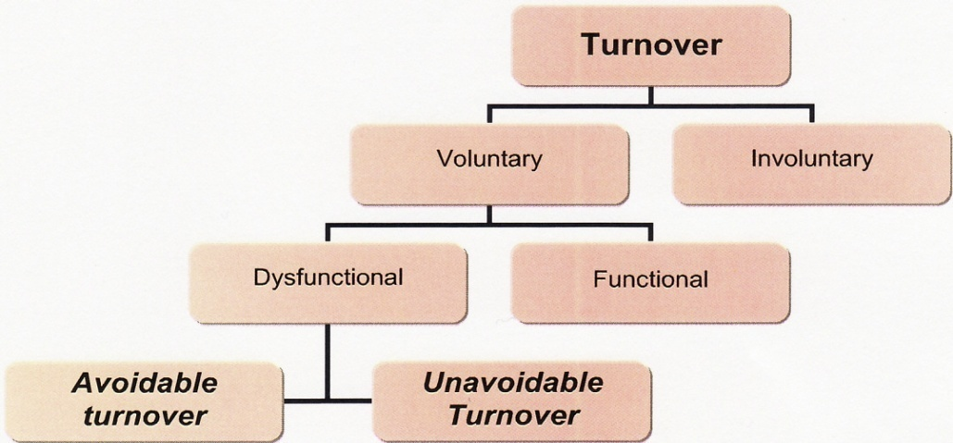

**Figure, 2.1- Types of turnover as cited in Lambert (2008)**.

The voluntary turnover is additionally separated into functional (leaving of low performance workforce) and dysfunctional (leaving of precious workers) as well. all over again this is separated into unavoidable turnover(family moved, serious sickness, or decease)on such situations companies don’t have focus whereas the another one is avoidable turnover, which is the most important point of distress for any company which makes up the most important element of turnover.

## 2.6-Adverse effects of increased employee Turnover in an Organization

Several drawbacks of increased employee turnover are as given below

## 2.7-Elevated financial expenditure of Turnover

The financial expenditure is more for staffing and training of new employees. For most, the HR managers recognize that the high cost of turnover adds thousands of Dollars to any company’s costs which include the expenses of the new workforce, training expenses and the loss of production output (Rita Dunn and Kenneth Dunn, 2005*)*. On the whole corporate experts estimate 25% of the average wages for the employee in traditional system.

## 2.8- knowledge drain, an asset of the organization

At the time of employee leaving an organization, he also carries the precious knowledge about the organization, business process, about the customers, current projects, clients and correspondingly the precedent history of the business which is advantageous to its competitors. More often than that a great extent of time along with weighty investment of capital has been spent on workers in expecting to obtain enhanced profits in future. Hence, when ever employees leave the organisation all these precious investments are lost. ([Jay Barney](http://hbr.org/search/Jay+Barney/4294841675%204294932927/), [Patricia Gorman Clifford](http://hbr.org/search/Patricia+Gorman+Clifford/4294841675%204294932927/), 2010)

## 2.9- Weakens Customer and Clients relationships

The employee takes away all the relationships cultivated with customers and potential clients when he leaves the organisation, which results in huge loss for the organisation because customers and clients give business to any company and the employees of the company maintain loyal relationships with the clients and that promote continued investment in the business. So, this all investment is lost when an efficient employee leaves the company, (Magda Barrera and Jody Heymann, 2010)

## 2.10-Low productivity until the new Employees are completely Trained

Whenever talented and skilled employee go away from the company it cause serious loss for the company as the newly appointed staff will take a some time to be trained fully about the process and it could cause low output and productivity for the organization. (Magda Barrera and Jody Heymann, 2010)

## 2.11-Turnover leads to more Turnovers.

When the worker go out of an organisation it probably leaves some impact on the emotional state of the workers left behind which may also leave a reason of worry among them in the company concerning themselves as well and prompt them to leave too. (Jack J. Phillips and Adele O’Connell, 2008).

## 2.12 Fundamental reasons of increased employee Turnover

All around they are different factors implicated to the increased rate of turnover of the employees which are explained as below:

53% of the professionals think that the major, frequent reason for employee turnover is the hike in the pay or promotion opportunities outside the organization as there is a dearth of exploring opportunities of career and development within the organization ,According to ACAS (2005),

## 2.13-Internal & External factors

They are many other factors which may be measured carefully as below

**Internal factors:** This is often described as push factors which are lack of encouragement and support from the existing organisation managers or the management.

**External factors:** They are also pull factors which are like getting an offer for promotion with better pay from the other outside companies or competitors.

Therefore for any company to increase the retention it is essential to lessen the probable internal factors and it’s always better to raise the internal opportunities of promotion incentives and pay packages.

## 2.14-Importance of retention in an Organization

*Retention* plays the very important role in any organization to control the brilliant and skilled employees. Retaining the best performers is the most important concern for several organizations in this competitive world (Chapman, Mary Boltz, 2009). Analysis and surveys shows that the lack of talented and skilled workers who have the top ability of performing at high standards will ultimately block the organisation capability to sustain with the competitors. For the success of any organisation in this existing competitive situation, Management should be ready with updated methods and procedures to attract the employees and make them to sustain in their organization to show their best abilities each day.

The retention of the capable, brilliant, talented, skilled and experienced workforce is a main focus of bloodthirsty competitive edge for any organization, According to King (2007). Correspondingly , the retention of the employee results in the steadiness of employees workforce which also results in the improving of the organizational standards, knowledge and also helps in the enhancement of procedures and quality with the help of continued developmental methods and it provides for a more consistent customers base as well. So, this is always very important for all the employers to recognize the viewpoints of workers regarding to their work profiles which they believe are very vital in order to direct them in to more loyal side of the company and to make them satisfied which ultimately helps in increasing the production. (Ventakesh,2009: Mulder, 2007).

According to Griffith et, al. (2008), even though there is enormous literature available on the employee retention that recognizes the factors which are responsible to make the employees to quit, but there is very less study focused on the factors relating to employees to sustain in the companies. In the same way, less research is made especially on how a worker thinks concerning his staying on with the same organization and correspondingly what are the factors which motivate them to create an attachment with the company. The basic strategies of employee retention have to be discussed in conjunction with the retention processes.

## 2.15-Which employees must be retained.

Lockwood (2006), suggest that withholding of the workforce must be focused on individual employees who plays very vital role in organization’s achievement and success as they hold the knowledge, talent, skills and professional experience which is necessary for on the whole success of the business. If there is high rate of increase in the leaving of top performers, organizations have to take risk of performance losses which consist of weighty replacement expenses and scarcity of potential ability. With this aim, many organizations want to retain top performers and highly skilful workers who bring strength and consistency to the organization. Griffith et, al. (2008), argue with the aim of defining turnover as index of functionally capable employees continuing and low skilled employees going away from the company. Before looking towards the probable ways of retention of employees, it also needs to look into positive ways to keep hold of the employees. There must be a comprehensible difference among voluntary and involuntary turnover for the reason that often turnover of the poor performers is beneficial for the company while the voluntary turnover of the capable or the skilled employees is always costly for the companies therefore the major focal point of the business is to retain the voluntary turnover of the capable and the talented performers. In reality, retaining capable and skilled employees for a longer time produces maximum highest output, improvement and stability for the organizational business, According to Hans0n (2006). It has been found that the majority of the turnover intention is age, personal commitments and job satisfaction, According to Lambert and Hogan (2009).

## 2.16-Role of Motivation and Professional satisfaction in retention of Employee.

There is enormous data accessible about the explanation of the concept of motivation and satisfaction of employees.

*Motivation* is defined as the progression of encouragement, correct direction and safeguarding of human behaviour for the accomplishment of organisational goals, according to Locke 2007),

***RETENTION***

**Figure, 2.2- Work satisfaction and motivation headed for retention of workforce**

While Locke (2007) explained that *Job* *satisfaction* is the outcome of motivational procedure.

On the other hand he also tells that there are countless imaginary views concerning the drivers of motivation, which leads on the way to a feeling of fulfilment to the employee. Several managers believe that satisfied employees are backbone for production.

## 2.17-Advantages of Employee retention to the Organizations

They are few advantages of employee retention to companies which are as follows

## 2.18-Retention saves new Recruiting Expenses and Time

Workforce is the greatest assets of every company. By losing the qualified people, any company will be in a serious difficulty. Therefore, in the long run, by means of retention of existing workforce an organisation saves lots of money. The huge expenses spent for the substitutes of a capable and skilled employee are approximate up to 70 to 200% of the yearly wages of that employees. According to Baverly and Jordan (2008).This will includes advertising marketing and recruitment expenditure, training expenses of new workers and reduced output or productivity until the fresh employee is completely trained and in addition the loss of the clientele who were more or less dependable on the employees who are leaving or left the company.

## 2.19-Retention helps to retain company’s Information or Knowledge

When any competitor recruits the talented employee, there is constant probability of loosing or exploiting key business knowledge, clients’ information, key data, strategies and secrets of the company. For this reason it is always very important to retain the employees in the company. According to Bill (2007), hiring of talented employees from the good companies is a greatest source of competitors challenging corporate knowledge. Therefore, competitors are always more eager to appoint these talented employees by giving them better competitive remunerations, offers and benefits as compared to their own company.

Currently many organisations think instead of hiring the talented employees from the competitors it’s always best to concentrate on how to attract and keep hold on best talented individuals and also they are more concerned about preventing drain of their own knowledge and skilled employees. There are few options available to attract and retain the talented employees

## 2.20-Various options Offered to retain Employees

According to Parker and Kleemeir (2005), many Organisations improve their productivity by providing best job satisfaction to their employees and by retaining them at their best. Particular approach for retaining employees is not been discussed in any literature because the reason behind is different organizations have different management approaches and cultures. There are few intrinsic and extrinsic factors been discussed to retain the employees in organisation.

**INTRENSIC FACTORS**

***1-Avoid calling employees in planned off time***

***2-Offer competitive wages***

***RETENTION REQUIREMENTS***

***HIGH EMPLOYEE TURNOVER***

***DIFFERENT WAYS OF RETENTION***

***3-Increase employee relations***

**Figure, 2.3- Parker and Kleemeir Diagram of turnover and retention model**

**EXTRENSIC FACTORS**

***5-Improved Training & development programs***

***4-Improved Reward management***

## 2.21 –Do not call Employees to work during planned Off days

One of the floor manager of Vodafone says that calling the workers on their planned off days and assigning heavy work load by covering with over time is one of the most important turnover reasons as well because this situation is very stressful for the workers. In addition to this it has seen that employees retain to their companies when there is no work pressure during off days and no calls from the management. (Longman, 2005).

## 2.22-Offering competitive pay rates to the Employees

Offering the competitive reward packages is very practical tool to encourage and retain the skilled employees, Mainly because the workers start thinking that they are not being valued by organisation if they are not paid and these employees are more open to even slight hike offers from the competitors in the market as they don’t have the job satisfaction.( Bill,2007)

## 2.23-Increasing employee Interactions and Engagements

According to the HR Manager of Vodafone it’s been concluded that if organisations engage employees with different internal competitive programmes, recreational meetings and professional creativities there will be higher rate of retention in the organisation. It also can be achieved by proper and frequent communication between management and staff, regular interactions related to goals, company missions, health and safety, employee suggestions etc. Management has to create such a relaxed environment in the office for employees providing all the opportunities for their career growth, providing different training and developmental programmes. To retain the employees’ organisations must make them to think that employees are the asset for their success and they value them in all manners. (web3)

## 2.24- Promotions, Rewards, and Appreciations of the top Performers

Recognizing the excellence of employees plays a very important role in retaining the top performers and it also creates the loyalty between the employees and the employer. Financial appreciation is the very important way in reward system. There are few rewarding factors which brings positive outlook in employees and this may increase the rate of retention. Few factors are offering flexible working programmes, conveyance facilities, special gifts on festivals, promotions, praising their efforts, giving them free day passes, family gatherings, working from home etc. (Lambert,E.G.2001).

## 2.25- Maintaining the employees Training & Development Program

With this fast moving economy and rapidly developing technology around us we need a workforce which has a focus on the future needs and adapts and skills themselves accordingly. Mostly it is the role of the manager to keep an eye on the personal growth of his staff in terms of the new technology.

There should be a development catalogue in the company which makes the employees aware about the ongoing trainings sessions and also the process cannot be completed without a regular feedback from the employees to maintain the quality and relevance of these training according to the needs of the employees.

A training program is learning process and thus needs to be updated, maintained timely and regularly. A learning process as given by ‘Kolb and Fry’ in 2009, which is still very relevant in today’s scenario is given below:

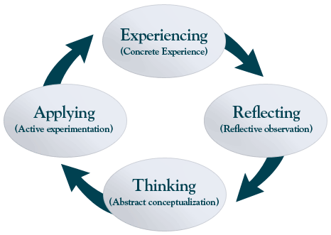

**Figure, 2.4 ‘Kolb and Fry’ Learning Model**

## 2.26- Relationship of Training and Development with Employee Retention

It is very important to provide the employee an opportunity to grow and develop in his job and carrier enhancing skills. This could be considered as the most important factor for motivating an employee in the organization.

External training classes and seminars disclose the secrets about what employees want for their training and development opportunities. However these opportunities can be found other than these trainings and seminars.

It is believed that these trainings create opportunities to develop devoted and growing employees who will benefit your business and will increase their own potential by going through this training process.

The result will be favourable to both the company and the individual. In any case it is a win-win situation for both the parties involved says (Vodafone Journal of Susan M. Heathfield, 2005).

## 2.27- Components of employee Training and Career Development Programs

There may be different reasons for employee training but one should make sure that it comprise of a comprehensive, consistent and ongoing employee training program. It is because of this quality of the program that your staff will stay motivated to learn new concepts and improve the profits for department. The training and development program is a process which works as a flow as given below by Gregory Pogue (2007)

**Figure 2.5,Training and Development Model by Gregory Pogue (2007)**

# The main elements of an employee training and development program as put forth by Gregory Pogue(2006) in his book “Employee assistance programs on liberal arts campuses,” first and foremost includes the policies and processes to identify the individuals who needs a push to improve their performance to the quality which organization is seeking.

For a training and development program the components that are quintessential are:

1. Top management commitment toward these programs.
2. Written and properly documented programs with policies and procedures.
3. Training programs focused on employees’ performance and efficiency.
4. Accountability and responsibility of immediate supervisors and managers.
5. Keeping and maintain a decorum of confidentiality.

## 2.28-Encouraging Learning and Development Programs

Human Resources Management Guide (2009) from UCSF states that you can:

"Encourage growth and career development of employees by coaching, and by helping employees achieve their personal goals at UCSF and beyond...[you can develop] human resources by providing adequate training... encouragement of staff development, and opportunities for growth."

The manager should first assess the skills and interests of the employees, then select training and other activities to propel a person to hone and nurture new skills in those areas. Further the employees are required to take initiatives themselves. Any person who is not willing to update himself with the new technology will soon find himself either out of work or the avenues.

There should be a development catalogue in the company which makes the employees aware about the ongoing trainings sessions and also the process cannot be completed without the regular feedback from the employees to maintain the quality and relevance of these training according to the needs of the employees.

The employee should also take initiative and should seek out the relevant trainings and activities to nurture his growth in the organization. In today’s world any person who is not willing to update himself with the new technology will soon find himself either out of work or the avenues become less and less for that person in order to succeed in his desired field.

## 2.29-Streamlining the process of Training and Development Programs

With this fast moving economy and rapidly developing technology around us we need a workforce which has a focus on the future needs, adapts and skills themselves accordingly. Mostly it is the role of the manager to keep an eye on the personal growth of his staff in terms of the new technology.

There should be a development catalogue in the company which makes the employees aware about the ongoing trainings sessions and also the process cannot be completed without the regular feedback from the employees to maintain the quality and relevance of these training according to the needs of the employees.

An example of streamline training is given by, Authoring Instructional Materials (AIM). It is basically a tool to progress and streamline the training and development process. AIM is used by Florida Navy in 2009, AIM works on Personnel Performance Profile (PPP).

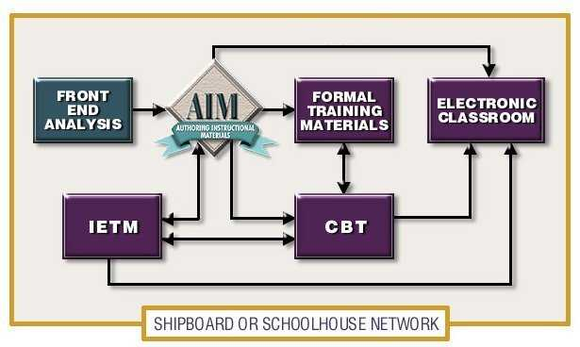

**Figure,2.6 AIM Navys Personal Performance Profile**

## 2.30 Planned Direction of Training and Development Programs

It is very important to understand the implication of a training program on the strategies of the company. Further the strategies, training and development programs need to be in line with each other for the development of the organization along with its employees.

The Marketplace Capabilities Group Inc.(,Emlpoyee Manual 2009) a management consultant company asserts that training is meaningful only if it can have a permanent effect on the behaviour of the company, which is in line with the organization’s long term objective. They give out the five step process training as below:

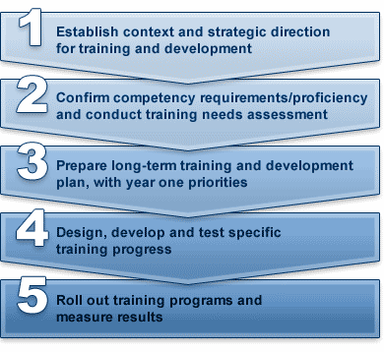

**Figure, 2.7 the Marketplace Capabilities Group Inc, Five Step Training Process**

Further the strategies, training and development programs a need to be in line with each other for the development of the organization along with its employees.

## 2.31-Hierarchy of Training and Development Programs

Personnel systems, human resource specialist organization( CEO Intervew in times india 2010)believes that different hierarchal levels exist in training and development programs. While level1 training paybacks the least, level three training paybacks the highest.

**Level 1**: It is the very basic level which relates to implementation of processes in order to maintain cordial relationship among the employee and employer.

**Level 2**: This level relates to developmental activities such as organizational and employees’ training and development in order to increase the effectiveness and efficiency of the employees as well as the organization. Initiatives taken at this level have developmental implications.

**Level 3**: This level relates to activities which has the possibility for vast payback to the organization. Initiatives taken at this level are very crucial and have strategic implications. At this level organization basically deal with the issue of macro level, such as demand and supply. These are the plans that broadly define the objectives and have the utmost effect on the organization.

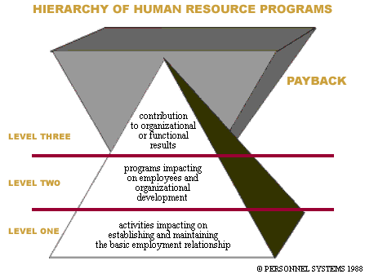

**Figure, 2.8 Personnel systems, Training and Development Levels**

Training and development at level1 training paybacks the least to the organization, while level three training paybacks the highest.

## 2.32-Effective implementation of Training & Development Programs

# As per S.E. Jackson, R.S. Schuler and S. Werner (2009) in their book “Managing Human Resources”, for effective training and development, proper implementation of training and development is a very crucial.

# Effective implementation of training is dependent on pertinent conditions and apt programs. If both the components are optimally utilized, most effective output of training can be achieved.

# One of the methods for effective implementation of training and development programs as given by emerald journal is below. Effective implementation of training is dependent on pertinent conditions and apt programs.

# http://www.emeraldinsight.com/content_images/fig/1050020202001.png

# Figure,2.8 Effective Training Implementation Programme By S.E Jackson, R.S. Schuler and S. Werner (2009)

# Optimal implementation of training is dependent on pertinent conditions and apt programs. If both the components are optimally utilized, most effective output of training can be achieved.

## 2.33-Process of Implementation of Training & Development Programs

# In the book “Managing Human Resources”, S.E. Jackson, R.S. Schuler and S. Werner (2009) discuss five components of implementation of training and development programs.

# The five components includes developing employees’ insight, motivation of employees, making them understand how to acquire the skill and imbibe training, providing them with opportunities to implement the training learning in real world, making the employees accountable for the training acquired.

# These five components are briefly described below:

# Firstly, *insight*, it is important for the individuals to realize what they do not know and its importance. Then only it makes sense to teach a process or provide skill development classes.

# Secondly, *motivation*, motivation forms a very important part in training implementation. Employee need to be motivated to an extent that they absorb maximum during the training. Without motivation, the urge to learn will come to a very few and can thus entirely bring down the basic aim of training. Also, during the training steps are to be taken to keep motivating employees.

# For example, incentives can be provided during training which may increase and give them an incentive to concentrate more. Also, prizes can be kept for evaluation at the end of the training, so that employees compete and learn the maximum.

# Thirdly, *how to acquire skill or imbibe training*, it is important to make the employees understand and be wary of the best methods to imbibe training. The design of the training be such that it automatically communicate this to the concerned people.

# Fourthly, *Practical learning*, if the training modules are taught in such a manner that the employees can practically apply them within reasonable time or during the training itself then the effectiveness of training increases to multiple times. In addition to that, it should be made sure that in regular intervals employees get to practice the activities and the skills they learned.

# As the time gap increases, the impact of training will reduce. Thus, it is pertinent that employees can practically apply them within reasonable time or during the training itself then the effectiveness of training increases to multiple times.

# Fifthly, *accountability,* it is imperative and reasonable to make employees accountable for the training provided to them. Employees when given responsibility for exhibiting the effectiveness of the training are likely to be more attentive during training. Also like the organizational hierarchy, it can be done that hierarchal accountability is created to keep a check.

Mictel Solutions which provides best practices pertaining to design and implementation services does also share a similar five component model as asserted by S.E. Jackson, R.S. Schuler and S. Werner (2009) in their book “Managing Human Resources”. The five components includes developing employees’ insight, motivation of employees, making them understand how to acquire the skill and imbibe training, providing them with opportunities to implement the training learning in real world, making the employees accountable for the training acquired.

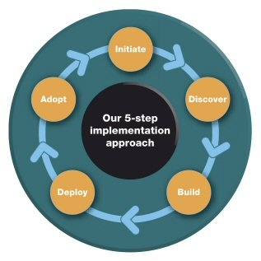

# 

# Figure, 2.9The model implemented by Mictel Solutions

## 2.34-Continuing Education in Employee Training

# Training and development at regular intervals is very pertinent. Its importance cannot be undermined in front of new hire training. [Jeffrey Bodimer](http://humanresources.about.com/od/resourcesreferenceshumor/a/Jeffrey_Bodimer.htm) asserts in his article (2009) “Use Training and Development to Motivate Staff-Building Your Employee Training and Development Program”.

# Nearly about 40% of information is retained in the training sessions that are held at initial level. Hereby a continuous effort is required from the organization to provide its employees training and development at regular intervals.

## 2.35-Formal and Informal approach of Training and Development

# [Jeffrey Bodimer](http://humanresources.about.com/od/resourcesreferenceshumor/a/Jeffrey_Bodimer.htm) in his article(2009) “Use Training and Development to Motivate Staff-Building Your Employee Training and Development Program,” discusses about two ways of training i.e. official or formal way of training and informal way of training.

# The informal way of training is more luring and immediately appeals to the person concerned. It is not a warning that the employees needs training, but a communication that they are given training lesson to improve their efficiency. The informal training way is liable to prepare the mindset in the organization that as and when any procedure changes, employees are liable to receive the impact of this.

## 2.35-On job Training and Development Program

On the job training and development programs is the best form of practical training. In this kind of training an individual since start is wary of practical procedures and learn whatever is relevant to the job. Thus it is ensured that all the parts which will be useful in job are covered in this type of training.

These types of trainings also suffer from limitations; implicit cost accruing to such training is ignored many a times. Thus it can be very costly as the true cost of such kind of training is difficult to decipher.

For example, an individual on ‘on-the-job-training’ might be taking help of many of his colleagues but their time quotient may not be considered in the cost.

It is also to be noticed that, these types of trainings also suffer from limitations; implicit cost accruing to such training is ignored many a times. Thus it can be very costly as the true cost of such kind of training is difficult to decipher

They have in practice on job training program for all the kinds of job present in the company. It addition to this they have kept qualitative and quantitative targets for the knowledge and skills to be acquired. They build specialized skills and professional capacity via real life experience.

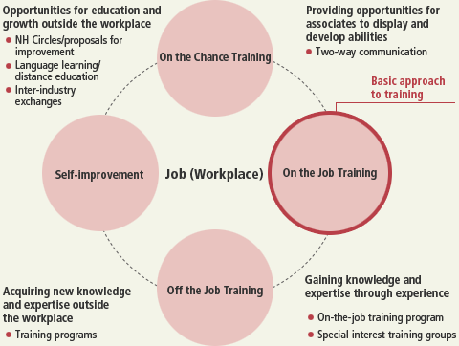

**Figure, 2.9 Flow chart of on-the-job training program**

## 2.36-Off-job Training and Development Program

# Along with on-the-job training and development programs, Honda also have specialized off-the-job training programs, which offer opportunities to their employees to augment their careers by imbibing new and valuable skills which will enhance their management capabilities.

# Vodafone provides different opportunities such as for learning foreign languages, enrolling for distance education programs and many types of exchange programs.

# In order to support their employees who desire to learn new skills, obtain knowledge and nurture themselves optimally to realize their capacity and potential, Honda company provides different opportunities such as for learning foreign languages, enrolling for distance education programs and many types of exchange programs.

# The off-the-job training and development program flow chart of the Honda Company is given below:

# Honda's Off-JT (Off the Job Training) system

# Figure, 2.9 Hondas off Job Training Model.

## 2.38-Need and Advantages of Training and Development of Employees

# J. Cheminais, G. Van Der Waldt, W. Fox and M. S. Bayat (2008) in their book ‘The Fundamentals of Public Personnel Management’, asserts that importance and advantages of training and development of employees is unquestionable.

# Firstly, *High rate of job satisfaction*, Different people in the organization come with different culture and attitude. In order to bring all of them on the same level, training is pertinent. It is required for the development and growth of an employee at an individual level.

# Secondly, *Enhanced employee empowerment and commitment to the job*, With the change in technology and new developments, it becomes essential for organizations to imbibe the change in the today’s competitive environment and thus training for specialized skills and regular development programs is a necessity.

# Thirdly, *Advantages of training and career development on workforce and on organization*, Training is required for the development and growth of an employee at an individual level. Thus when all the employees grow the organization also grows.

# Fourthly, *Enhanced loyalty and meaningfulness*, In order to boost the morale of employees and keep them abreast with the new developments training and development programs are pertinent.

# Fifthly, *Performance of the motivated employees,* Proper timely support and guidance not only boost their morale but also increases their efficiency and effectiveness.

# The need and advantages of training and development of employees is aptly exhibited in the diagram below given by Dr. Alan Nankervis & Dr. Cecil Pearson (2010) in their book ‘Research and Practice’, Human Resource Management.

# http://t2.gstatic.com/images?q=tbn:ANd9GcQZLJT46uZkhRtbCkaCQnjdfo7p877VRD_JT0Mmdv38CmaN2ww&t=1&usg=__u7fJejr7FODxt1qP8YUmgyI8jEE=

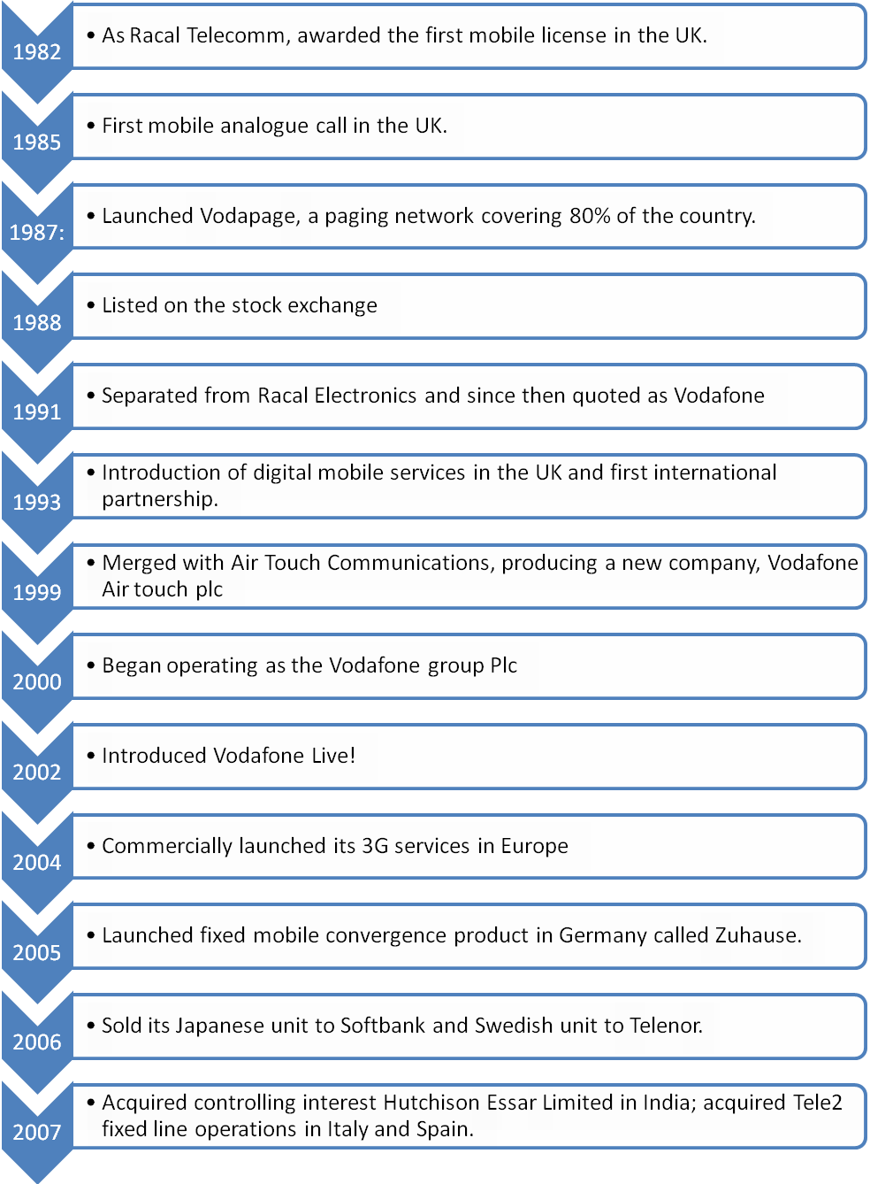

1. To get the full project, please buy the Assignment by using this Link
2. <http://sampleassignment.com/pay-now.html>
3. Cost - £39