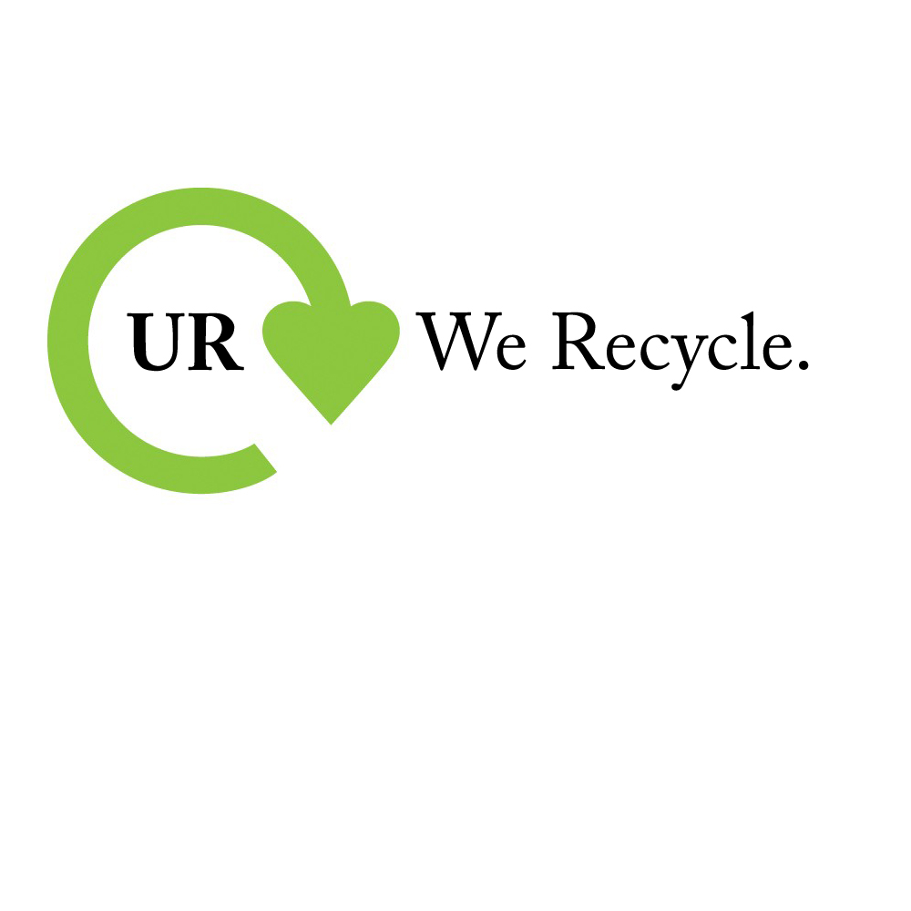

**ULIMATE RECYCLERS**

**COMPANY PROFILE**

**Ultimate Recyclers** is an India based company with the motive of Solid Waste Processing using Multi Product Recycling and Waste Minimization. The basic principle is to extract usable, commercially viable end products out of the Municipal Solid Waste (MSW) and create processed residue of less than 20% of the input volume. The plant’s capacity is approximately 500 tones/day and an output generation of 66 tones of Compost, 116 tones of Green Coal and 54 tones of Plastic Granules per day.

* Capability to handle Wet and Solid waste along with Inert Waste.
* Complete Recycling Solution with Green Recycling Technology Recycling to Green Products.
* The end result output adaptable to customer needs.
* Reduction of the Mixed Waste by 80-85%.
* Reduces financial burden for Municipal Solid Waste Disposal on the Urban Local Bodies
* Aligned to the CSR requirements.

**RECYCLE** with Ultimate Recycler’s Green Technology.

**REUSE** Ultimate Recycler’s Green Products.

**REDUCE** your waste by 80%.

**PROCESS**

**BUSINESS OUTLINE**

**MISSION:**

* To reduce the waste amount produced by the region.
* Protect the environment by serving to the maximum potential.
* Ensure the hygiene and reduce the burden of the City Municipality.
* Control pollution and safeguard the interests of people of that region.

**VISION:**

The heart of Ultimate Recycler’s business is about preserving, maintaining and improving environment and searching out sustainable solutions that complement progress. It practices and propagates a Green Way of Life and encourages the society to choose sustainable, low-waste, recycle-friendly and environment-conscious initiatives.

**MOTTO:**

“Where **Garbage** turns **Gold**”

**MISSION STATEMENT:**

To become a leading, innovative waste solutions company committed to continuous improvement for customers and environment around us. With the support of our employees, we aim to grow our company whilst maintaining successfullong standing business partnerships with both our contractors and customers.

**SOURCE OF FUNDS**



**PROFILE OF DIRECTORS**

**Hitesh Adhukia**: He has pursued his Bachelor’s Degree in B.Com F&A and Master’s in Business Administration from Christ University, Bangalore.

**Riya Mehta:** She has completed her Bachelor in Business administration from St. Xavier’s College, Kolkata and her Masters in MBA from Symbiosis, Pune.

**RaghavShroff**: He has completed Mechanical Engineering from VIT, Vellore.

**LOCATION**

The location of this plant is at a very convent location. It is located in the industrial area of Sachin, Gujarat which is just 10Km south of the city of Surat so that the waste materials can be transported to the plant very conveniently. Due to NH 6, the transportation of the waste will be hassle free.

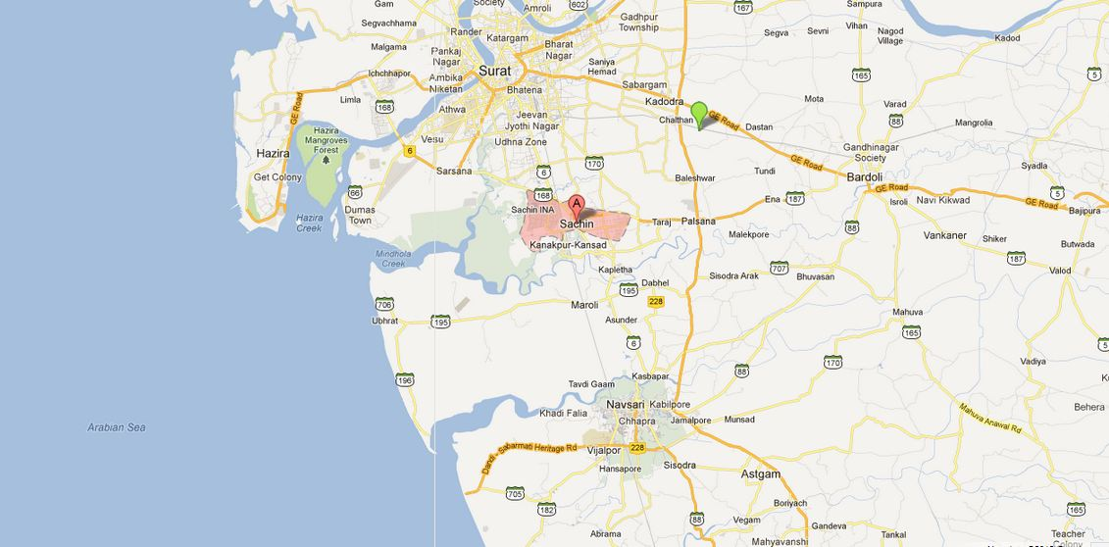

**PLAN SUMMARY**

* Our UR plant is a recycling plant based in Sachin, Gujarat.
* The government of Gujarat gives away the garbage free of cost to recycling plants.
* There is no Sales Tax, Value Added Tax and Income Tax as a part of subsidy by the state government.
* The plant is spread across 1,21,406 sq. mt. (30 acre) which is given to us on a lease basis for Re. 1/sq. mt. per year for a period of 200 years.
* The location of the plant is approximately 10Km south from the city of Surat which is just off-road of NH 6 for easy movement of waste material.
* The products we deal in are:

1. **Wet Organic Waste(25%)** converted into **Compost.**
2. **Dry Organic Waste(30%)** converted into **Solid Recovered Fuel**.
3. **Recyclable Materials(20%)** converted into **Plastic Ingots** and other **Recyclables.**
4. **Inert Material(15%)** is converted into **Sand** and the rest is dumped into **Landfills**(10%-15% of the Mixed Waste).

**PROCESS**

Waste processing is a Six Staged Process. No segregation of the waste is done at the source, hence the entire waste is taken into the processing plant wherein end stage segregation is done, to segregate waste into **Wet Organic Waste, Dry Organic Waste, Recyclable and Inert Materials.**

**INITIALISATION:**

The waste from the city is brought in dumpers into the waste processing plant wherein it is weighed and taken for other stages as processing.

**SEGREGATION:**

The entire waste undergoes second stage of the entire process wherein it is taken into Segregation, wherein it is segregated into three components, namely:

1. Wet Organic Waste
2. Dry Organic Waste
3. Recyclable Waste (Plastic, Metal, etc.)
4. Inert Materials

The segregation is done owing to the material having specific gravity. The material is allowed to pass through a conveyer belt wherein the dry waste and wet waste is segregated as latter being heavier, settles down. Then wet waste taken to further processing, while dry waste is segregated further into recyclable material, wherein metal and useable plastic is taken as scrap and sold for recycling.

**WET OGANIC WASTE:**

The wet organic waste comprises about 25% of the total waste. Wet waste sprayed in the composting yard where heaps of waste is made and left for aerobic digestion. Regular spraying of water is done to enable speedy digestion. The heap is left for 40 days during which the heap is overturned manually regularly so as the aeration is received. After 40 days, the wet waste transforms into O**rganic Compost**.

**DRY ORGANIC WASTE:**

Dry waste forms 30% of waste which utilized for making **Green Coal** or **Fluff.**

1. **Sorting** - The materials which are large in size and are of high calorific value are sorted from platform sort conveyer belt.
2. **Low Calorific Value** –The material is diverted on the basis of size or green material with low calorific value for composting.
3. **Wood and Paper –** The carried forward material which are paper and wood, are put forward for shredding.
4. **Crushing –** The dry waste is now crushed so as to reduce the size.
5. **Fluff –** The Fluff is now either compressed for densification or is directly fed into the boiler.
6. **Storage –** The compressed Green RDF Fluff are either stored for boilers or are sold in the open market.

**MARKETING**

**MARKETING STRATEGIES:**

* Organizing educational camps in the villages in and around Surat so that the farmers get to know the benefits of Organic compost and substitute inorganic fertilizers with them as they are cheaper and are readily available from UR.
* Providing first hand information to the different industrial units in the region of Surat so that they substitute coal with Green Coal or RDF.
* Supplying the plastic granules to toy factories so that fresh production of plastic is reduced which helps to keep the Earth a better place to live.

**UNIQUE SELLING PROPOSITION (USP):**

**COMPOST –** Compost is made by recycling Wet Organic Waste.This compost gives 50% more output if used with chemical fertilizers.

**PLASTIC –** Plastic at UR is recycled and helps in reducing requirement for fresh plastics.

**GREEN RDF –** Green RDF has low content of sulphur and plastic and has calorific value equal to that of coal. It can be used in factories instead of coal as it gives less emission.

**PRODUCT:**

India being a country with majority of its population in agriculture, needs viable and cheap fertilizers. In the present scenario, the agriculture sector is moving towards a safer and a less toxic substance. Hence they are adopting Compost and other natural substances in large quantities.

**PRICE:**

* Compost will be sold at a price of Rs.10/Kg.
* Green Coal will be sold at a price of Rs. 3/Kg
* Plastic Ingots is sold at a price of Rs

**PLACE:**

The plant is located at 10 Km south of the city of Surat. By this, the transportation of the waste materials to the plant and finished products from the plant is made easy especially due to NH 6.

**PROMOTION:**

A sales manager will be appointed who will travel to leading whole sellers and industries to advertise about the Green Products and their advantages so that they shift to a healthier and more efficient method of production.

**PROFILE OF PERSONNEL EMPLOYED:**

**GENERAL MANAGER:**

He should have completed Graduation with good Hard and Soft Skills.

**ACCOUNTANT:**

He should have complete knowledge about Book Keeping and Computer Accounting.

**ENGINEER:**

He should have completed the course with a distinction.

**MAINTENANCE STAFF:**

He should have in-depth knowledge about the working of all the machines.

**OFFICE STAFF:**

He should have an experience of at least 2 years in this industry.

**FOREMAN:**

He should be able to handle all the workers efficiently and effectively.

**SECURITY:**

He should be very sincere in their duty and will entertain no nuisance inside or outside the premises.

**WORKERS:**

He should have the enthusiasm to work hard. The thought of conserving the environment should be his motivation.

**SWOT ANALYSIS**

**STRENGTH:**

* The government has a major contribution to this project. Providing land at such rate has drastically reduced our cost.
* The location is also very convenient as it allows the mixed waste material and the finished products to be transported easily.
* The finished products are sold in the market at a very affordable price.
* We use the most modern technology to recycle the waste materials and conserve te environment.

**WEAKNESS:**

* The number of sales personnel is less in number as the target market is very small.
* The market share is low as there are bigger competitors in the market.
* As the end product is mostly used in other industries, Direct Marketing is not viable.

**OPPORTUNITY:**

* Waste is produced daily in the company and the amount of waste cannot come down due to increasing population.
* The other city’s Municipal Corporation might get interested in this technology and adopt it in their region also which will help reduce pollution nationwide.
* The existing plant can have tie-ups with Municipal Corporations of other cities which will reduce the amount of waste going in the landfills.

**THREAT:**

* The main threat for the company is the difficulty in obtaining permission from the government to set up the plant in that location.

**STP ANALYSIS**

**SEGMENTATION:**

**DEMOGRAPHIC SEGMENTATION:**

These include factors like age, social esteem, and income levels which purely relate to purely population related characteristics the masses possess. For UR, the main consumers will consist of farmers who will use compost as their fertilizer and who use eco friendly fuel such as RDF.

**GEOGRAPHICAL ESGREGATION:**

This takes into consideration the region to which the customer belongs to or prospects to visit. The UR plant is located in such an area that the compost can be used by the number of farmers and the RDF/Green Coal cabe used to power the factories in that region.

**BEHAVIOURAL SEGMANTATION:**

It is based on the benefits derived from the services offered, usage of the services by the population and the social status enjoyed by the population. The benefits that the consumers derive from the services and the utility of the products determine the acceptance and complete acceptance of the services offered.

**TARGETING:**

Targeting the right customers is one of the most important criteria that need to be looked at in order to create a potential customer market. Our target customers will be the heavy pollution causing industries so that they switch over to a healthier power source and the farmers so that they use an eco-friendly source of fertilizer.

**POSITIONING:**

The UR plant will be situated 10Km south of the city of Surat which is a very ideal location as it has good road connectivity and the Waste Materials and the finished products can be transported safely and with proper care.

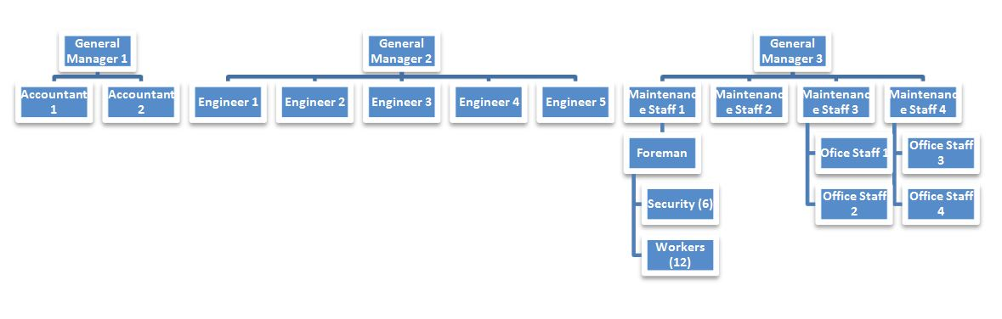

To get the full project, please buy the Assignment by using this Link

<http://sampleassignment.com/pay-now.html>

Cost - £29