Global environmental change – Raising an Alarm
Student Name:
Student Number:

Course Code:
Date:
Instructor:

Referencing Style: APA

Introduction
Environmental science is a combination of academic field that brings physics and biology to the study of the environment, and helps in solving the problems of the environment. Environmental science gives a desegregated, measurement, and interdisciplinary approach to understand the system of the environment. The study in general includes the description and analysis of environmental study and environmental engineering. The objective of this paper is to critically analyze the topic of global environmental change and relate it to the theme of environmental science. This paper makes use of several issues related to the field of environmental and highlights cases where global environment change has become a cause of serious concern for the regulatory authorities of several nations across the globe.
The paper uses the articles in order to discuss the findings of the topic in the form of a literature review. A discussion is included to preset the main findings of the paper. The paper ends with a brief conclusion which ties the contents of the report together (Aucamp et al, 2007).

Significance of Environmental Science
The study of the environment is related to understanding the human relationships, interpretation and policies concerning the environment with the help of social sciences. Environmental engineering targets designing and improving the technology for better quality of the environment in every strand. Scientists of the environment work on topics like comprehending the processes of the earth, calculating different system for energy, controlling and reducing the pollution, management of natural resources and the impacts of the changes in climate on earth (Baker, 2000).
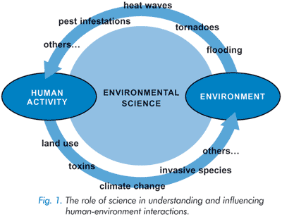
(Newman, 2005)
Issues of the environment mostly contain collaboration of processes of physics, chemistry and biology. Scientists have introduced an approach of systems for the analysis of problems of the environment. The key elements of this analysis involve the capacity to convey space, and time relationships along with qualitative analysis (Khare et al, 2002).
Following are the components of environmental science:
Atmospheric sciences: Under this component, spotlight is on the atmosphere of the earth, with focus on its relation with other systems. It consists of the study of meteorology, phenomena of greenhouse gas, disappearance of atmosphere due to formation of airborne contaminants
Ecology: it is the study of the interaction between organisms and their environment. The investigation is done between this relationship

To get the full project, please buy the Assignment by using this Link
http://sampleassignment.com/pay-now.html
Cost - £19

